My name is Tereza Navrátilová. I’m 15 years old. I live in Myslibořice with my mother. My father live in Třebíč. I go to secondary school in Třebíč. I like play vollyball. I have a dog, her name is Jessie.
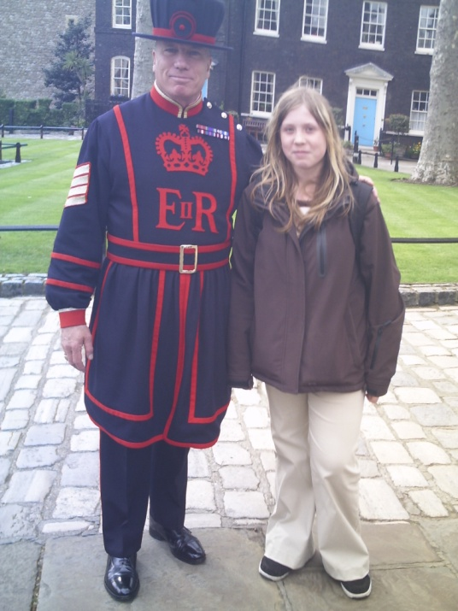I in a London. I and my dog Jessie.
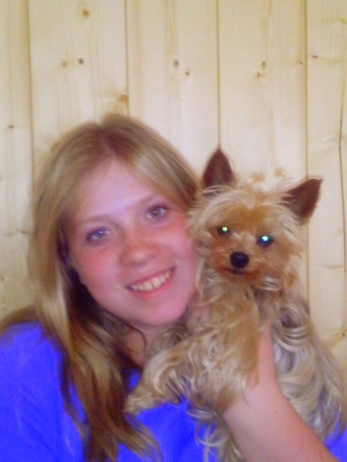

I and my mother in Beskydy. I and my cousins near grandmother.
