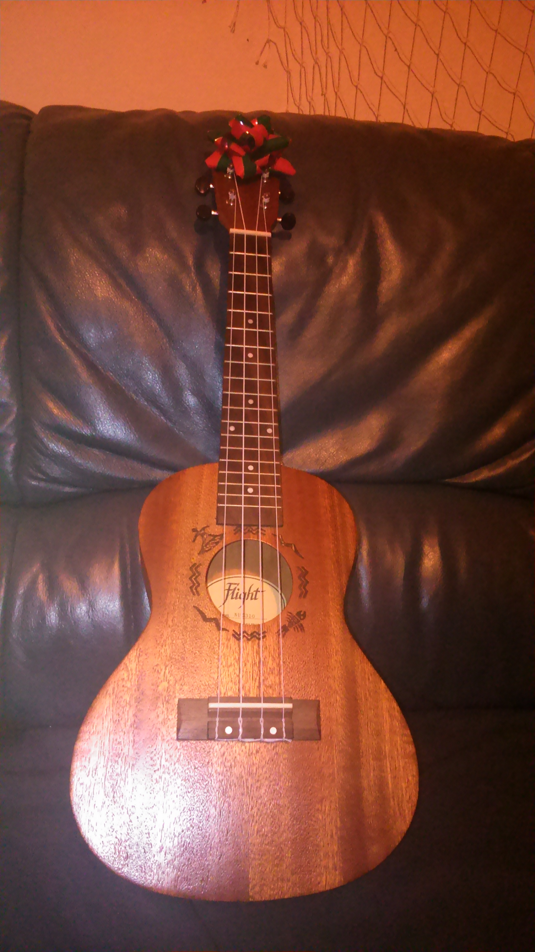Hi. My name is Vojta Kafka. I´m 16 years old. I study a secondary school in Třebíč. I live in Náměšť nad Oslavou. My hobbies are fishing and many sports. I play the ukulele. I like nature, animals, theatre and army. I am interested in history, army, nature, school and theatre. My motto is DUM SPIRO SPERO.
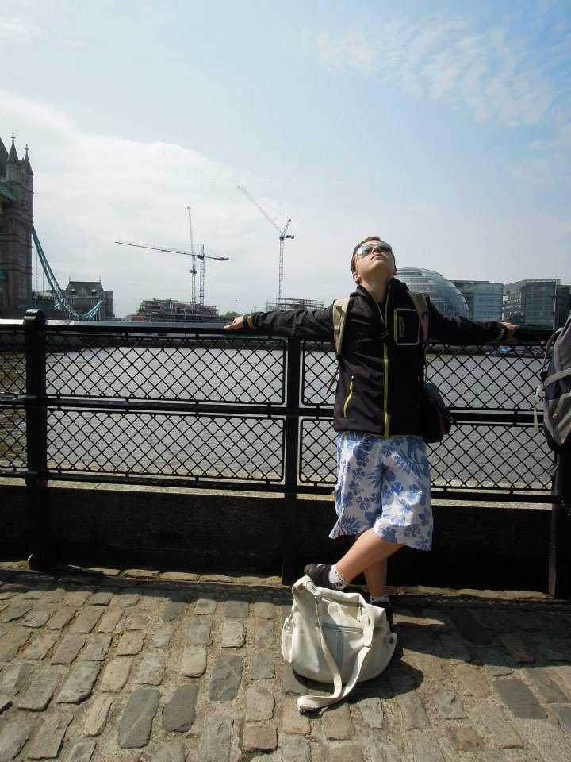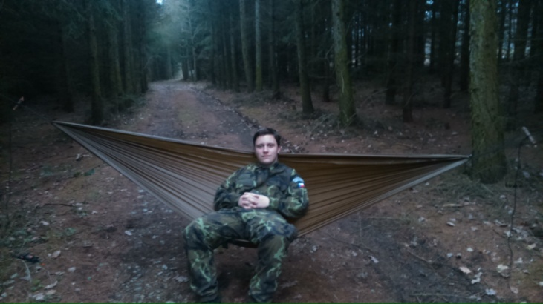

This is my ukulele.
I am in a hammock.

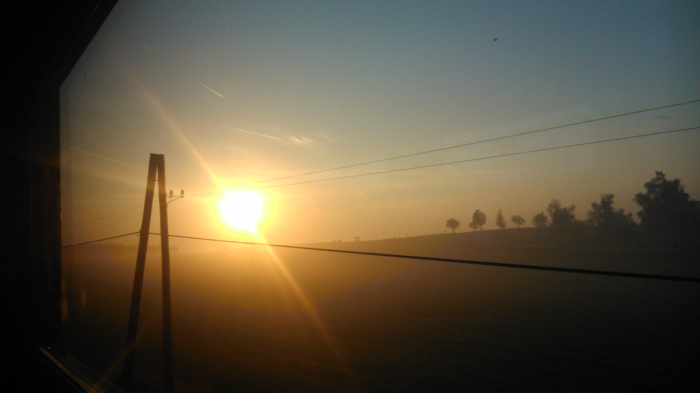

A morning on the way to Třebíč.

I am in the United Kingdom.

