The French teenagers girls favourite singers, actors….:

I- Actor :
Their favorite actor is Rayanne Bensetti. He plays in Pep’s and he is in the program Danse avec les stars. He is a young actor of 21 years old.

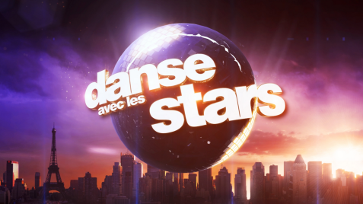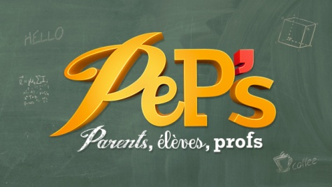

II- Singers:
Their favorite singers are : Soprano and Kendji Girac.
Soprano is a French rapper of 35 years old. He sings Cosmo and French Prince. He has just released his album and he is very popular.
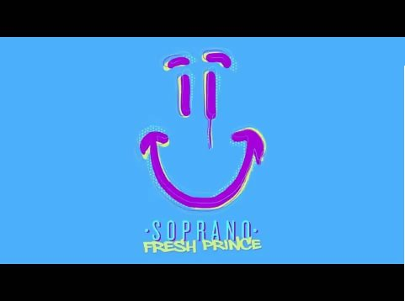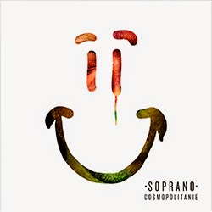

Kendji is a young French singer too of 18 years old. He sings “Color Gitano” and “Andalouse”. He has just released his album and he is very popular too. He played and won The voice, a program about singing.
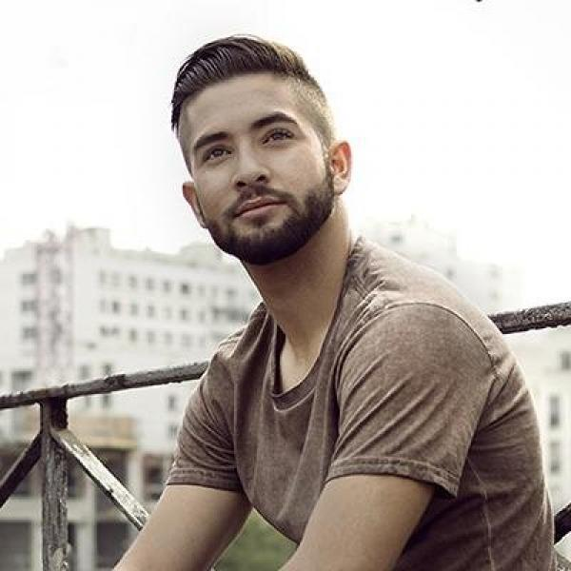
III- Group:
Wati B is their favorite group. It isn’t really a group, it is a label and some singers belongs to it like Black M, The Shin Sekaï, Maitre Girm,…

VI- Movies:
Their favorite movies are Qu’est ce qu’on a fait au bon Dieu and Nos Etoiles Contraires.
Qu’est ce qu’on a fait au bon Dieu is a french comedy about a family. It deals with racism and religion but in a funny way.
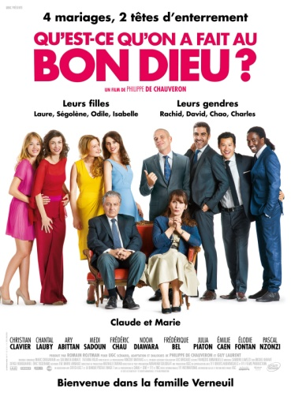
“Nos étoiles contraire” is an American movie. It’s a love story with a serious sickness.
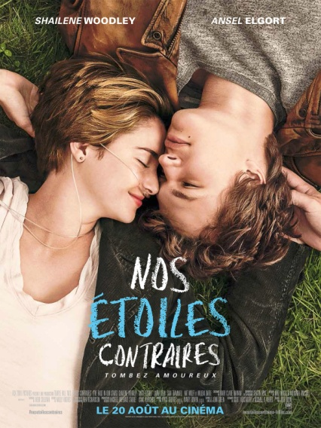
V- Song:
Their favorite song is Fresh Prince from Soprano. It’s a song about a party in a club.
.

VI- Video Game:
Their favorite video game is The Sims 4. It is a game with an avatar and his life.
