TRADITIONAL FOLKLORE CZECH SONG AND DANCE “Babsky z Korně“

A) Folklore costumes, dances and songs in the Czech Republic
The Czech Republic has a rich tradition of folklore songs and dances. Also in almost every village or town, people used to wear clothes typical for that place. The folklore costumes were often decorated with ribbons, flitters, and embroidering. The folklore costumes changed during time and in the last century people slowly stopped wearing them. Nowadays, we can admire folklore costumes in museums or during folklore traditions.
B) Historical background of the song and dance “Babsky z Korně”
Ostrava is a city situated on a border between Moravia and Silesia region, it is very close to Poland and Slovakia. People who worked in Ostrava´s factories were coming from the surrounding villages and even from Slovakia which was part of the former Czechoslovak Republic. They brought their traditions, dances and songs with them.
We will teach you a special song and dance called BABSKY which means OLD WOMEN´s. It is a kind of "Czardas" which women from both sides of the Czech and Slovak border used to dance in the pub "U Janošča" in the Beskydy Mountains near the village Bílá, which means white. Women used to sing this song late at night when men got tired and decided to have a drink or a chat.
C) Description of the dance
This dance has a special character; the pace during the three stanzas gets faster. Women usually sang one stanza and then danced, sang another stanza and danced and the last part was the fastest. Each pace corresponds to a different kind of dance step. It is danced in a circle; dancers are facing inward, holding their hands crossed behind their backs. It is possible to change directions.
1) Make a circle. Hold your hands.
2) The first pace is very slow; make the steps with slightly bent knees. Make two steps to the right and two steps to the left. Repeat. Then make four steps to the right and four steps to the left. Count with music: one – right leg makes a step to the right, two – left leg moves to the right and stand on your tiptoes, three – put down your heels, four – stand still on both feet, and then repeat.
3) The second pace is faster. The whole circle is moving to the right. Make a step with your left leg and cross it in front of your right leg. Put only front part of your foot on the floor and bend slightly in your knees. The left hip moves in the circle, both shoulders are turned inside the circle. The next step is with your right leg. Straighten your left leg, and put energetically your right leg next to it. Your feet should be close to each other, touching the floor, especially the heels. The left foot swerves and the left hip gets in the starting position.
4) The third pace is the fastest. Hold the hands behind the back with a person who is not standing directly next to you. Lean slightly. The whole circle is moving very fast. Cross the left leg in front of the right leg. Bend slightly in the knees. Then make a step with the right leg, the foot is not too far from the left foot, stand on tiptoes, weight is on both feet. Then repeat. Do not turn with your hip or shoulders in the circle.
1) Read the Czech words and guess their English meaning. Check your answers. Then write these words in your language.
a) beloved, b) evening, c) fire, d) got a fever, e) has got a headache, f) head, g) hurts, h) in the fire ring, i) is burning, j) last night, k) my, l) yesterday

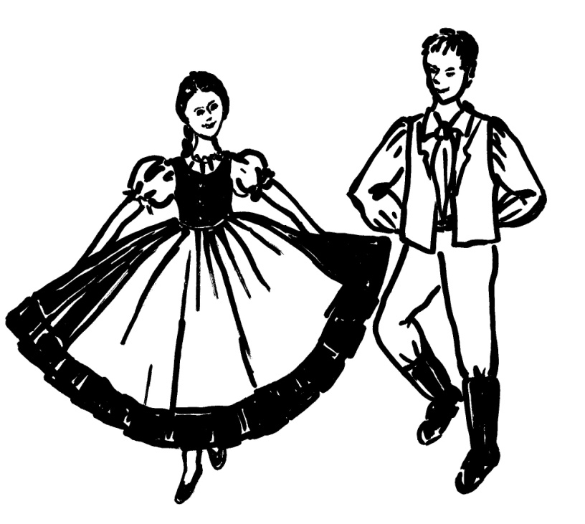

1) Na ohnišču – h) in the fire
2) Oheň – c) fire
3) Horí – i) is burning
4) Moju – k) my
5) Milu – a) beloved
6) Hlava – f) head
7) Bolí – g) hurts
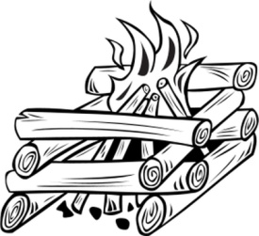
8) Hlava boli - e) has got a headache
9) Včera – l) yesterday
10) Večer – b) evening
11) Včera večer – j) last night
12) Zahorela – d) got a fever
2) Read the English version of the song. It is not the exact translation; some words are different than in the old Czech song so that it is possible to sing it in English version too.
3) Listen to the song. Then read slowly the Czech words. Finally learn to sing and dance the song.
