European Values: FAIRTRADE - worksheet with answers

1) Make little groups of 3 – 4 pupils and answer these questions:
a) Explain what “Fair-trade” is: Fair-trade is organization which main goal is to set the Fair-trade certification standards, to give the minimum price for the Fair-trade goods, promotion of Fair-trade logo, organizing campaigns for support of the fair trading. The Fair-trade organization has two main purposes: to eliminate child labour and to make sure that a farmer gets fair price for his product. Fair-trade also means fair selling and buying products. It gives people from Africa, Asia, and Latin America a chance to make living with their work. Its goal is to guarantee that people work conditions respect human rights and that farmers are paid for their hard work a fair wage. Only farmers who respect living environment can get the right to use the Fair-trade logo. The children whose parents work for Fair-trade cooperatives can go to school.
b) Which Fair trade products do you know? Chocolate, juice, cocoa powder, clothes, juice, bananas, tea, sugar, nuts, coffee, rice, dried fruit
c) How are most of the Fair-trade products made? Most of them are handmade.

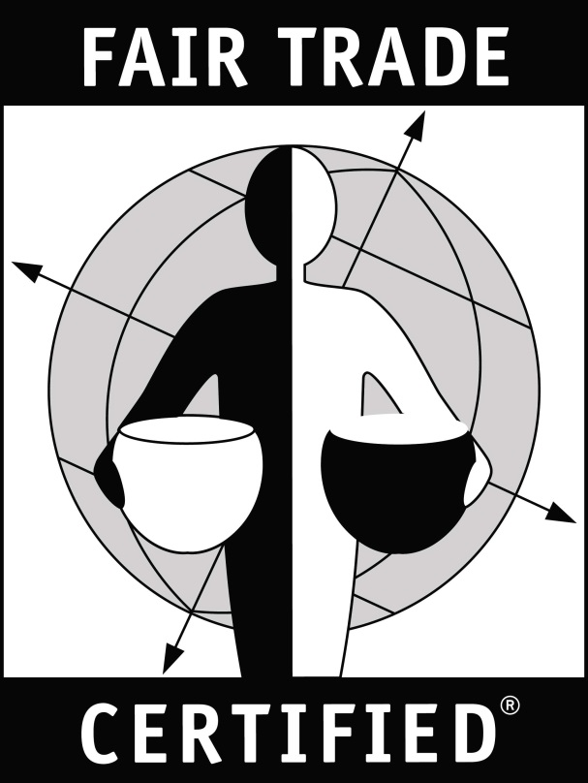
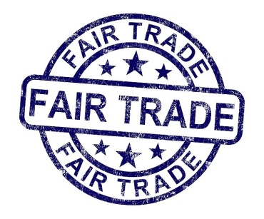
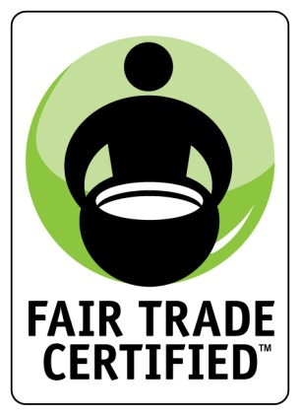
2) Which of these pictures represents Fair-trade logo? All pictures are Fair-trade logos
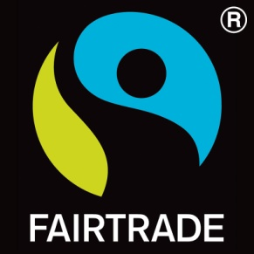
a) b) c) d)

3) Read the text in the box. Then check your answers from task one.
Name “Fair-trade” was first used in the Netherlands in the 80s in the last century. Max Havelaar Foundation introduced the first product fulfilling the Fair trade criteria, coffee from Mexico, in 1988. The first Fair trade organization was founded in Great Britain in 1992 and its first products with Fair trade logo were produced in 1994. The first Fair-trade products were connected with handmade goods, nowadays the most traded Fair-trade goods are coffee, cocoa, sugar, and tea. The seat of Fair-trade is in Bonn and its main goal is to set the Fair-trade certification standards, to give the minimum price for the Fair-trade goods, promotion of Fair-trade logo, organizing campaigns for support of the fair trading. One half of the elected board are representatives of the Fair trade cooperative producers mainly from the developing countries.

4) What do you know about tea? Where is it grown? How is it changed into the tea which we drink? Why is tea important for people? Then watch presentation and check with your ideas.
Tea is a cultural drink and has medical benefits. Tea is the second most spread drink on Earth, after water. The drink is prepared from leaves. Tea is part of culture but it has also medical effects on the body because it contains vitamins, minerals, anti-oxidants and even it is cancer prevention. Good and quality tea helps to find the lost balance, encourages, strengthens, and energizes. These may be the reasons why the number of the tea-lovers is growing. Tea is very closely connected with human society. People drink tea for breakfast, when they meditate, relax, during cultural and social events, and it can also heal.
Check your answers for tasks 1, 2, 3: http://www.slideshare.net/alenaholas/presentation-fairtrade-tea
The correct answers for the quiz at the end of the presentation: 1a, 2b, 3b

5) Answer these questions then watch presentation:
a) Do you know where you can buy Fair-trade product in your town? Where?
It is different in each country, probably in the international chain shops. In the Czech Republic it is Mark and Spencer, Starbucks coffee, Tchibo, Billa supermarket, Droxi Market (DM drugstore), Bio food, Teta (drugstore)
b) Have you ever bought a Fair-trade product? What was it? .......................................................
c) Here is a list of Fair-trade products. Choose five which you are most likely to buy:
chocolate, juice, cocoa powder, clothes, juice, bananas, tea, sugar, nuts, coffee, rice, dried fruit
..................................................................................................................................................................
d) What do you know about cocoa? Is it a plant, a bush or a tree? It is a bush.
e) Chocolate seeds are covered by ....banana.......... leaves to dry. They dry at .......50......°C.
f) Look at task c, which of the products were the most popular in the Czech Republic in 2008?
The most popular is chocolate, the second was coffee, the third most popular was tea.
g) How often people buy the Fair-trade products? Match the frequency and the number:
Never 19% I am not sure 15% Yes, but rarely 36% Sometimes 24% Regularly 7%
7% 15% 19% 24% 36%

h) How much has declined child labour since 2 000? By one third
i) How many million children have to work? More than 100 million children work (168 million)
j) How many children must do hazardous work? One half (85 million which is more than one half of children in labour)
k) Where is the highest child labour? Match the areas with number of working child population:
Sub-Saharan Africa is the region with the highest number of child labour: 59 million (over 21%)
There are 13 million (8.8%) of children in child labour in Latin America and the Caribbean.
In the Middle East and North Africa there are 9.2 million (8.4%) working children.
l) How many children work in the most important sectors, mostly in the informal economy?
Agriculture remains the most important sector where child labourers can be found 98 million (59%). The problem of child labour is also high in services (54 million) and industry (12 million)
m) Fill the words in brackets in the gaps: Child labour among ...girls........... fell by 40% since 2 000, compared to 25% for ....boys............. . (boys / girls)
n) Write some reasons for buying Fair-trade products:
Fair-trade products guarantee that they are children labour free. Workers get fair salary, at least the country minimum wage. Their working conditions are no inhuman. Fair-trade cooperatives improve the living condition of the whole community. It is one of the way how to help people in the developing countries.
Watch and check your answers: http://www.slideshare.net/alenaholas/presentation-of-fairtrade-products

