ISTITUTO COMPRENSIVO “Marconi-Oliva”- LOCOROTONDO
Piazza Mitrano,30 - tel. e fax080-4311074 - Cod. Mec. BAIC83100B - C. F. 91108250720
e-mail baic83100b@istruzione.it
70010 LOCOROTONDO

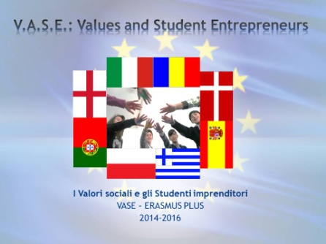

V.A.S.E. Values and Student Entrepreneurs

ERASMUS PLUS 2014 -15
2014-1-ES01-KA201-003680_2
Activity CHART
  - ACTION OF THE PROJECT
Title of the Action
A poster for V.A.S.E.
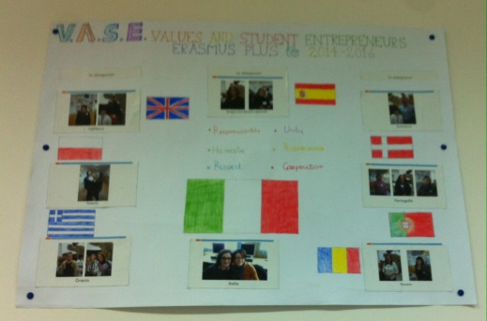

1.2 Person Responsible of the action
Prof.ssa Giusi Savito

1.3 Objectives
Objectives and topics
- Develop awareness about our project and getting familiar with it and its purposes
- Enhance creativity
- Increase teamwork abilities
1.4 Time required
The activity was started on 10th December 2014 and was completed on 17th December 2014

1.5 Human Resources
 |  | 2014/15 | 2015/2016
Teachers | Planning : Giusi Savito ( Erasmus + V.A.S.E. team member)  Poster Editing: Vittorio Mirabile  Dissemination and online uploading: Vittorio Mirabile  Event management: Giusi Savito | 6 hours
Class | 2B

1.6 Brief description of the action
 | 2014-2015 | 2015-2016
- Focus on the objectives of the project, presentation of the nations and coordinators involved through slides and photos.  - Brainstorming and poster designing | 10.12.2014
- Making of the poster | 15.12.2014
Filming the activity and making of a video by using Power Director 13. Uploading of the result on the project Facebook site. | 17.12.2014

Locorotondo, ______________
ITALIAN COORDINATOR
Prof. Paola Masciulli

