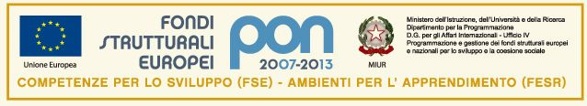
ISTITUTO COMPRENSIVO “Marconi-Oliva”- LOCOROTONDO
Piazza Mitrano,30 - tel. e fax080-4311074 - Cod. Mec. BAIC83100B - C. F. 91108250720
e-mail baic83100b@istruzione.it
70010 LOCOROTONDO

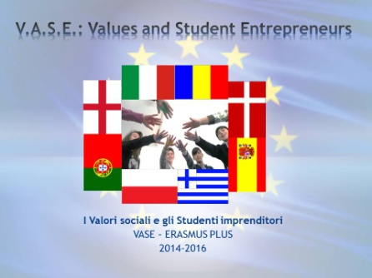

V.A.S.E. Values and Student Entrepreneurs

ERASMUS PLUS 2014 -15

2014-1-ES01-KA201-003680_2
Activity CHART
  - ACTION OF THE PROJECT
Title of the Action
Tradition Day
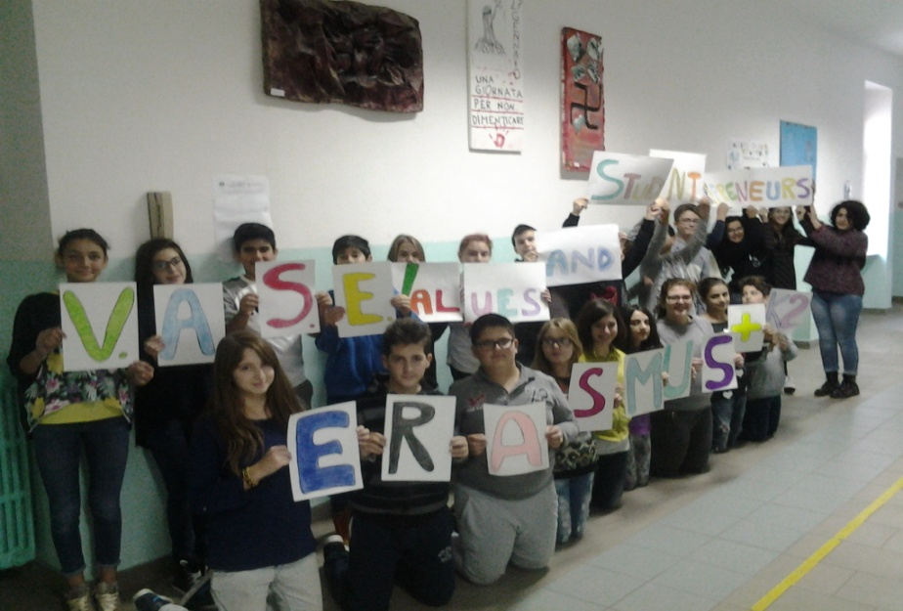
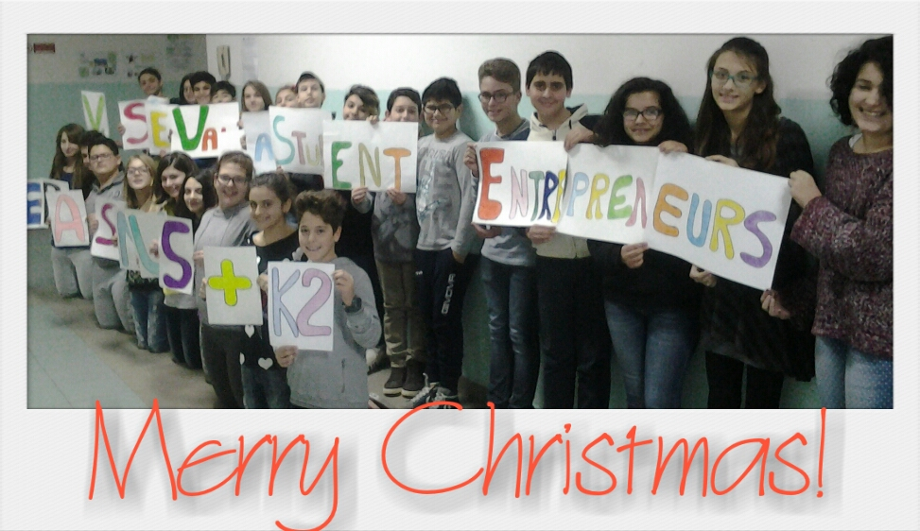
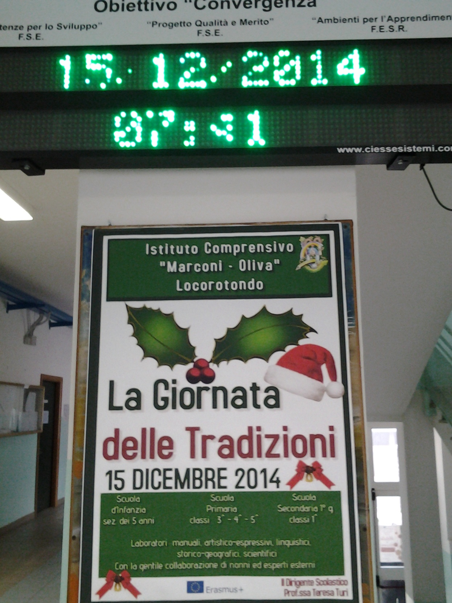

1.2 Person Responsible of the action
Prof.ssa Paola Masciulli (Italian coordinator)

1.3 Objectives
- Increase awareness of universal values in the students, in order to share them and achieve a better relationship with themselves and with the others
- Enhance a personal research
- Experience and learn a variety of ways related to communication and self expression
- Share experiences and emotions with other people
- Learn and understand local traditions
- Develop teamwork competences

1.4 Time required
All the actions described have been implemented on 15 December 2014

1.5 Human Resources
 |  | Anno 2014 | Anno 2015
Teachers | Photo reportage of the event, diffusion and online uploading of the event: Paola Masciulli  Organisation and editing of the VASE Banner for the event: Paola Masciulli | Tot 4 hours
Class | All first classes of the secondary school and class 2F

1.6 Brief description of the action
 | 2014-2015 | 2015-2016
All students have been involved in the following workshops carried out by expert volunteers:
- Scented rhymes (recipes)
- My town traditions
- Christmas in dialect
- Christmas Origami
- Sounds and songs from the local traditions
- Weathers in Locorotondo in old sayings
- Display of the outputs from the workshops
- Making of rhymes, Christmas cards, drawings
- Traditional songs played by traditional instruments
- Research on customs, habits and traditional believes
All actions have been photographed and filed. The students of the V.A.S.E. Erasmus + project have sponsored the event by making a very large project banner, by supporting the values of their town traditions and by recognizing their importance as fundamental basis to build a solid and reliable future. We live in a world where everything keeps changing rapidly and some important features of our cultures seem to fade away during this process. As one of the main objective of our project is to develop social values in our students, to foster entrepreneurship and to enhance creativity and innovation, our students have been challenged to face the importance of knowing past traditions in order to find new creative ways to move on, without losing the sense of being part of a specific culture and identity. All those activities listed above considered relevant and suitable for the implementation of the V.A.S.E. project have been uploaded online on the project Facebook and blog sites. They will also be posted on the project Etwinning site and school website both in Italian and in English, including the making of Christmas cards made at school during the event.

Locorotondo, 22 December 2014
ITALIAN COORDINATOR
Prof. Paola Masciulli

