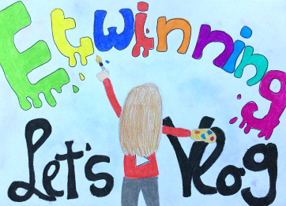
Setting up a YouTube channel
eTwinning Project Let’s Vlog!

Name of the channel
Write the name of your channel and explain why you have chosen this name and what it means.

Target group
Describe your target group – who is this channel for (e. g. teenagers interested in video games, girls interested in fashion, football fans etc.). Explain why you have chosen this target group.

Description of the channel
Topics I want to focus on in my videos:
Type of videos (funny videos, tutorials, travel vlogs, reviews etc.):
How often you want to post a new video (e. g. 1 video a week, every Friday etc.):

People involved in running the channel
Will you run the channel on your own or will anyone help you? What will the other people do?

How to be successful
Describe what you will do to become successful.

Channel and cover picture
Paste the pictures that will represent your channel.

Intro video
Record your first video that new visitors will see when they visit your channel. (If you use the template, paste the link to your video.)

Information about your channel for the visitors
Write a catchy introduction for the visitors.

