Backstage slips
Students had fun. Yet some mistakes and slips went through all the Lab work, especially on transformations (translations and rotations) and Geogebra script. They first worked with the teachers, then by themselves. No one was left in back. There were peer scaffolding and peer review for the students who needed help. They were stubbern, creative and competitive, but when needed cooperative. They liked to explore and investigate.

Scaffolding

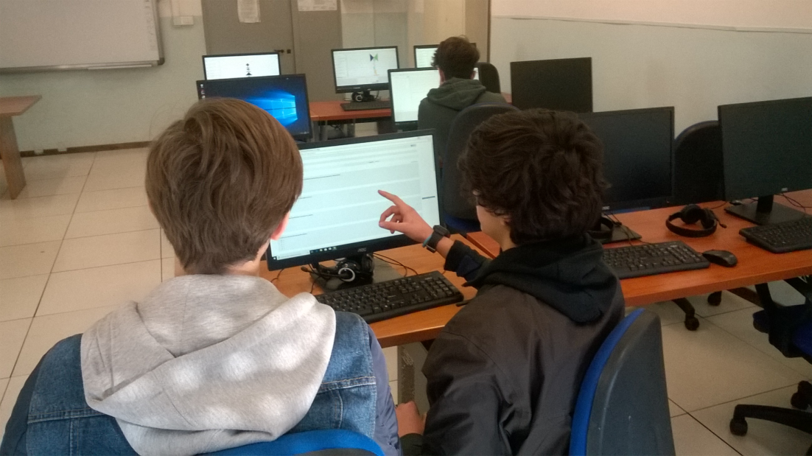

Working on TANGRAM and Art Works

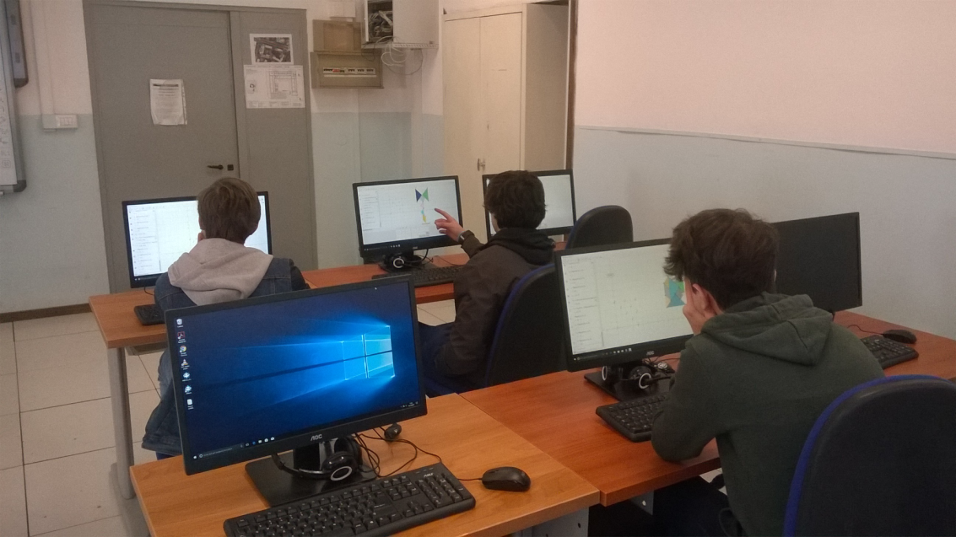

Working on TANGRAM and Art Works
