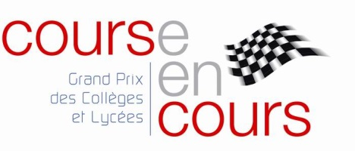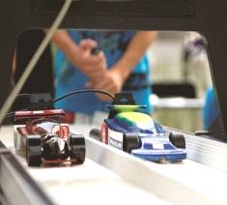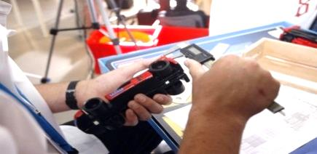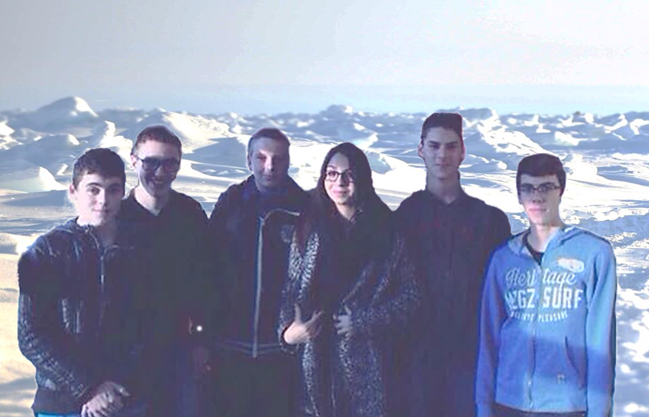

**We are looking for partnership**

**Reasons to sponsor us :**

* Some advertising
* a Social Action

**One year to create the next car of the future**

We are student in Institut Lemonnier In Caen and we are first year students at the Institut Lemonnier in Caen, France. We study SI (Ingineering Sciences ) and CIT (Technological Creation and Innovation) We take part in the association and competition Course en Cours.

Course en Cours is an original and educational system, based on science and Technology.

Teams are composed of 4 to 6 students of secondary and high School. They must imagine, design, make, test and race the mini car.

As real professionals they use the same tools and method: one part of their project is marketing and communication.

**Who are we?**

Our team shares the values ​​of PASSION, of SPEED and SKILLS needed for this competition.

We have chosen the topic of the North Pole, and of the polar bear, which lives there, hence our name NANOOK ("Spirit Bear" in Inuit). The bear is the Lord of Ice, a symbol of power and strength. It is considered as a protective animal. Nowadays, it alerts the Man on the future of the planet.

We seek to make an innovative car respectful of the environment. It will respect the balance of the three pillars: economic, environmental and sociable. All sponsors, financial, services or materials will be stamped on our portfolio, our clothes and our display alongside the official sponsors who have invested for years into the project. They come along with us at the I.U.T in Alençon for the regional fuel and in Paris at the Ecole Polytechnique, for the national final.

**ARMAND DEVILLEZ**

DESIGN ENGINEER

A continent, A passion

Course en cours, a national competition…

**ALEXIS JUIN**

GRAPHIC DESIGNER

**CLEMENT RACINET**

TEAM LEADER

**JEROME SOISSON**

MANUFACTURING ENGINEER

**OCEANE GROLLEAU**

RESSOURCES MANADGER

**KILLIAN MARGENAITRE**

TEST MAKER