G1
G2
G3
G4
G5
G6
G7
G8
G9

Around the car

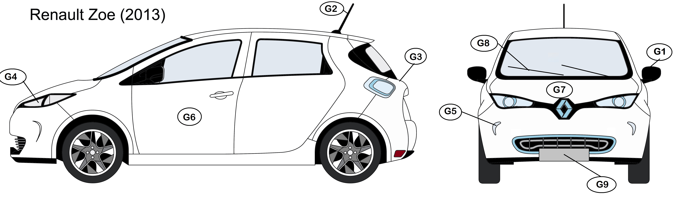
And, were is the plug to recharge the battery ?

