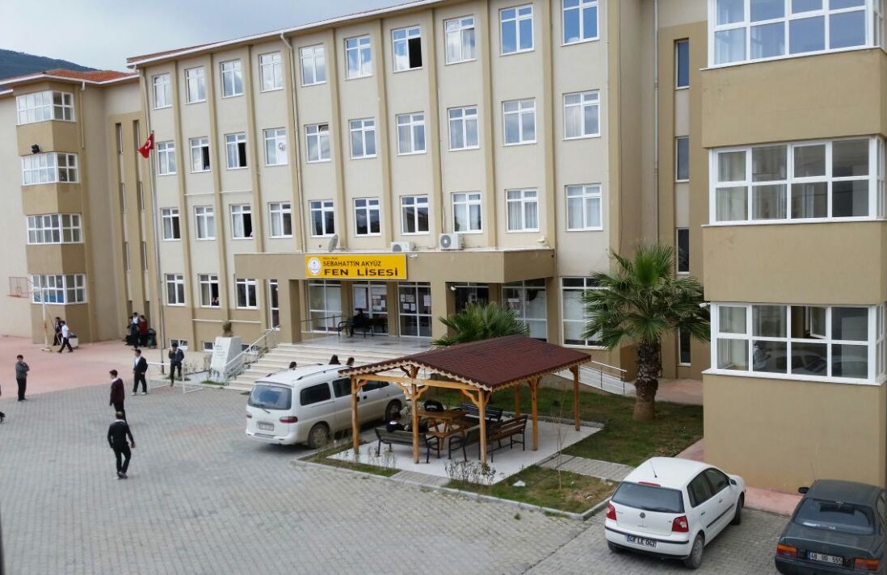
Schooyard
Main entrance
Teachers’ cars
Arbour
Our School

Atatürk’s bust

From the window of our dormitory, we can see our school. Our school has two entrances. You can see the main entrance in the picture.
In front of the school there is our schoolyard where we spend our time during breaktime.
In front of the school there is also an arbour. We have a rest there in our free time.
There is Atatürk’s bust in front of school as well (Our well-known leader). All the schools in Turkey have it in their garden.
There are some cars in the school garden. They belong to the teahers.

