From our Windows
ACTIVITY 2
form: groupwork
4 groups, each group has one side of the school
STEPS:
1) Take a photo from a window of the school
2) Download it to your computer/tablet
3) Copy it to the Word (or another programme)
4) Label it in English
5) Write a description about what you can see.
Language to be used. For example:
In the photo present simple / present continuous
There is / There are
We can see
It seems to be
colours
on the left/ on the right/ at the bottom / in the background / in the centre / in font of / in the front / behind / next to /
Don’t forget descriptive adjectives, e.g. nice / shabby / modern / old
and your opinion

Example description:
dining hall
flags with prayers
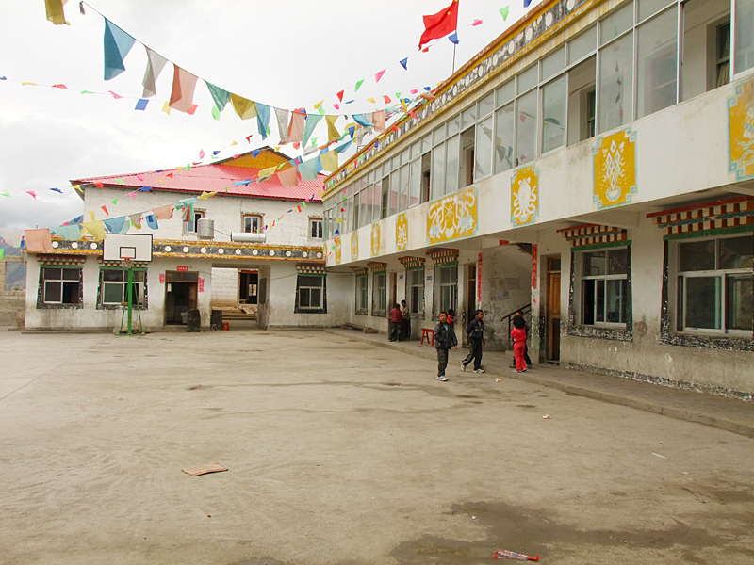
basketball stand
yellow and white pictures of flowers
library
school yard
From the window of the classroom on the first floor we can see the school’s yard. It is quite large but not modern. On the ground there is just soil, no modern surface. On the walls you can see dirty spots. On the other hand, there are also yellow and white pictures on the walls of our school canteen. There are flowers painted in them. What is very interesting? Of course, the colourful flags hanging from the roofs of the school buildings. They are stretched across the yard up in the air and make the atmosphere much nicer and playful. They are for prayers! They bring luck and happiness to all people around them.
We usually spend our break there or we go there after the instruction. In this photo there are our classmates on the right side. They are chatting together, maybe about the lunch Several metres behind them there are our teachers standing. They must be speaking about us or the lunch too. In the background, in front of our library, you can see a basketball stand with a basket. We love playing it.
That’s our school yard seen from the geography-classroom window.

