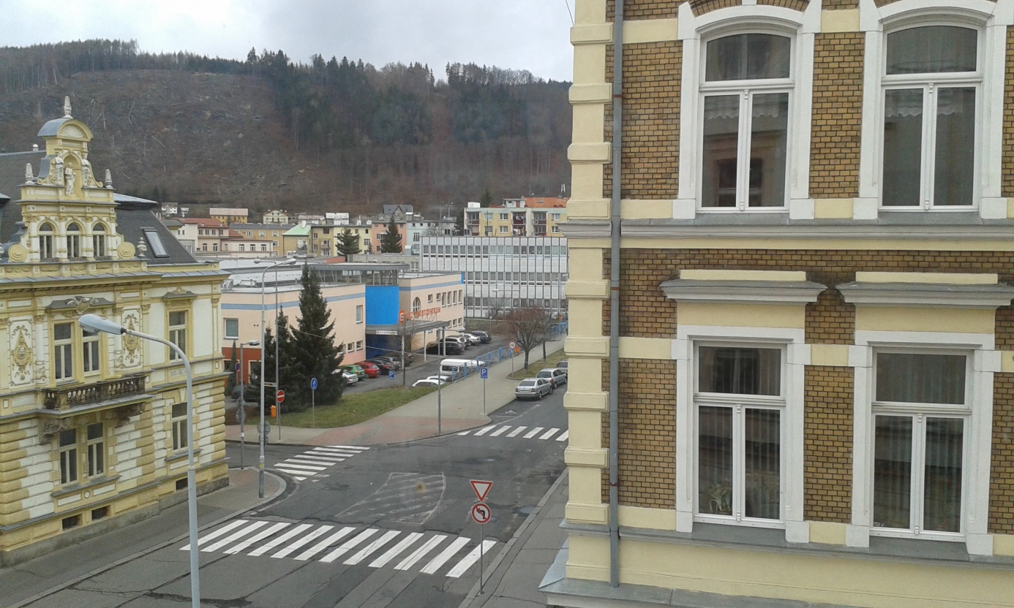
Primary School of Jan Amos Comenius
House - privately owned
Sports hall
School canteen
From the window of our V4.A classroom on the second floor we can see a primary school. It is called after one famous Czech teacher Jan Amos Comenius.
There is also a sports centre. We can play basketball, volleyball or other activities here. In this hall there plays a basketball team, which is very good in our country. There is a fitness centre, too.
Behind the sports centre there is our school canteen. We like meals there. It is the white building.
On the left in the picture there is a house, which is privately owned and people live in many flats there.
When it is after school children from our school and from the primary school go to the canteen for lunch.

