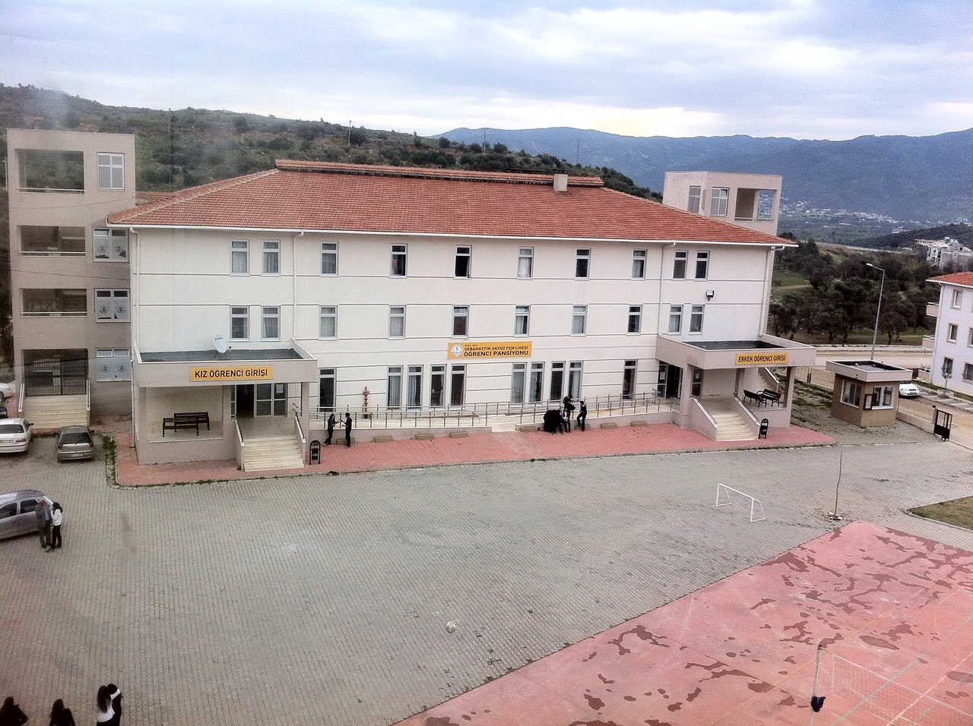
Schoolyard
Garden entrance
Our Dormitory

vv

Small room for on duty student

From the window of our school, we can see our school dormitory. 42 boys and 84 girls stay in the dormitory. On the first floor there is a dining hall. There are two entrances.
The school yard is in front of the dormitory.
We can also see the entrance of the garden in this picture. We have 10 minutes break after every lesson. We usually go to the school canteen or have a walk around the garden. We have one hour and twenty minutes lunch break.
On the right there is a small room for the student on duty.

