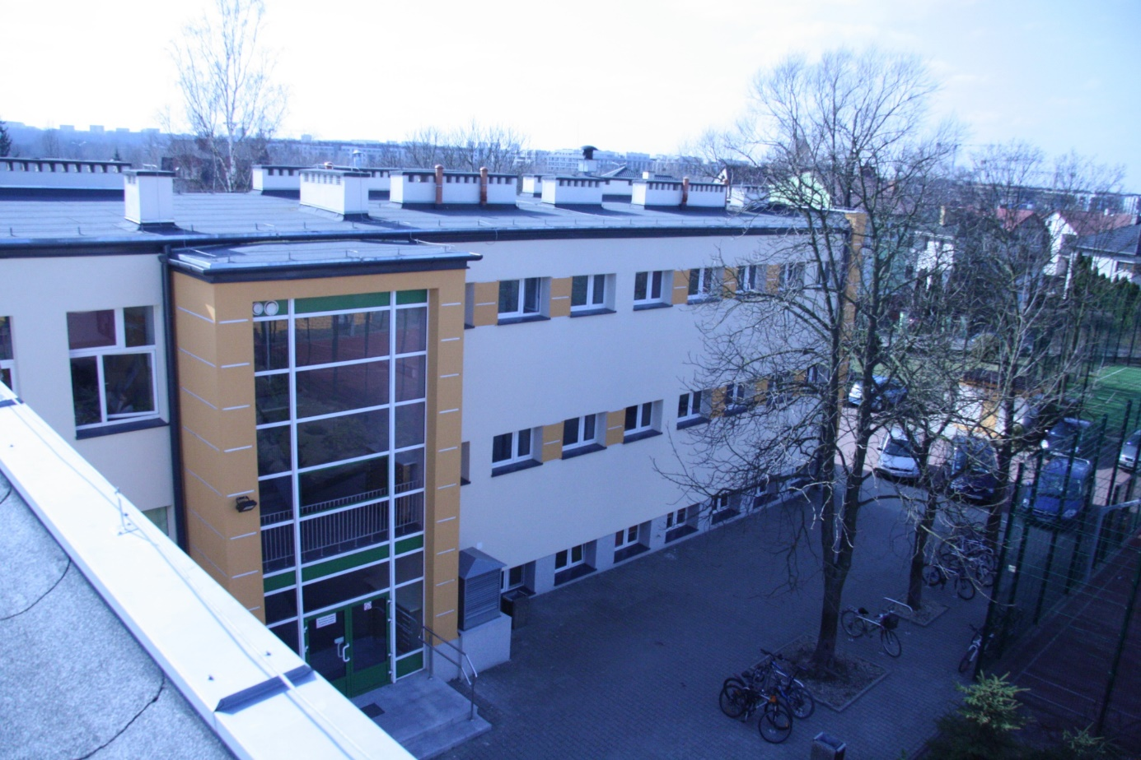
Temple of Divine Providence
prov
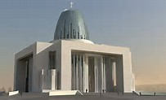

Undergound Canteen

School’s Doors
Bicycles Holders

Between old building of school and basketball court is entrance to secondary school. Many students go to our school by bike, which is visible at the bottom of the photo. Near bike stands there is small parking for school employees.

