CLIL LESSON PLAN
AGRICULTURE
(Teachers: Laima Baltutienė and Laima Šalkauskienė)

Subject: ICT, English language, science

Title: “Agriculture”

Age Group: Secondary School (12 - 15)
Intermediated, Mixed Ability Class
B1 according to CEF (Common European Framework)

Group size: 25 students in class (3-4 pupils in a group)
Timing: 40 – 45 minutes
Place: Computers` Lab

Learning outcomes:
1. To introduce the concept of agricultural history and its benefits;
2. To analyze what are the most common types of agriculture in project partners‘ countries;
3. To find out what agriculture types create the biggest amount of jobs in Europe.
Language Objectives:
To enrich their vocabulary about agriculture.
To practice finding information on internet and using CANVAS and Quiz programmes.
To develop written English and the collaborative skills.

Activities: students will watch the video about agriculture. Discussion, work in groups and create a poster.

Detailed sessions: the lesson is divided into four parts: the beginning of a lesson using "brainstorming" to find out what students know about agriculture. Watching video and discusssion about the agricultural concept. Then students using the program CANVAS create posters representing the states of their agriculture. Later, with the program QUIZ consolidate acquired knowledge in the test. Groups present their posters.

SESSION 1
Students are asked to answer the question: „What is agriculture?“ Brainstorm the ideas. Students are given the task to find the odd words and pictures which are not related to the agriculture and underline them.
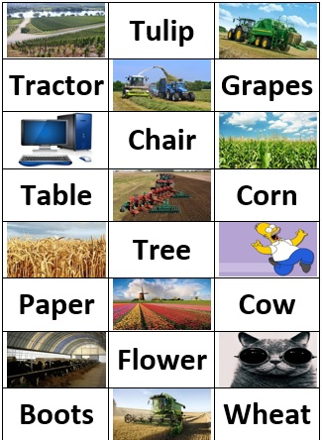

Video task:
https://www.youtube.com/watch?v=twGev010Zwc&list=PLWXYrBnq4Jh2T-pQ5e9mzixDGnp7asuk4 .
The answer to the question „What is agriculture“is given and then students discuss the right answers of the „words and pictures“ task.
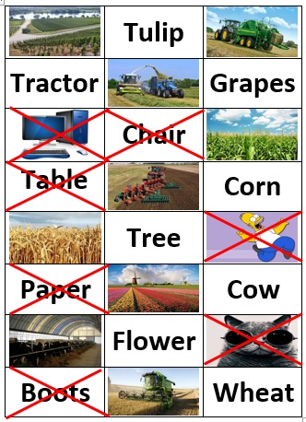

SESSION 2
Students are given the questions hiden with qr code. Then regarding the questions they have to create a poster using the programme https://www.canva.com/ .

SESSION 3
Students solve the croosword searching information in Internet. https://quizizz.com/admin/quiz/58bfeceb37e63813188eae41 .
SESSION 4
Students presentations of the posters.
SESSION 5
Count the results of the groups.
Resources:
http://www.investbulgaria.com/BulgarianMaps.php
http://ec.europa.eu/agriculture/sites/agriculture/files/statistics/factsheets/pdf/bg_en.pdf
https://en.wikipedia.org/wiki/Agriculture_in_Bulgaria
http://ec.europa.eu/agriculture/sites/agriculture/files/statistics/factsheets/pdf/ro_en.pdf
http://ec.europa.eu/agriculture/sites/agriculture/files/statistics/factsheets/pdf/ro_en.pdf
https://www.emis.com/php/store/reports/RO/Romania_Agriculture_Report_20162017_en_547322770.html
http://ec.europa.eu/eurostat/statistics-explained/index.php/Agricultural_census_in_Poland
https://eaap2015.syskonf.pl/agriculture
http://ec.europa.eu/eurostat/statistics-explained/index.php/File:Figure_7_Irrigated_area_by_type_of_crops_Spain.PNG
https://www.britannica.com/place/Spain/Agriculture-forestry-and-fishing
https://www.google.lt/search?q=agrikult%C5%ABra&source=lnms&tbm=isch&sa=X&sqi=2&ved=0ahUKEwift8GgmOjSAhXDkCwKHW-FDFoQ_AUIBigB&biw=1242&bih=602#tbm=isch&q=haumeris&*&imgrc=yuK0NvnsIX6nRM:
https://www.google.lt/search?q=agrikult%C5%ABra&source=lnms&tbm=isch&sa=X&sqi=2&ved=0ahUKEwift8GgmOjSAhXDkCwKHW-FDFoQ_AUIBigB&biw=1242&bih=602#tbm=isch&q=tulpi%C5%B3+laukai&*&imgrc=1ED2xOyYGUfWWM:
https://www.google.lt/search?q=agrikult%C5%ABra&source=lnms&tbm=isch&sa=X&sqi=2&ved=0ahUKEwift8GgmOjSAhXDkCwKHW-FDFoQ_AUIBigB&biw=1242&bih=602#tbm=isch&q=vynuogi%C5%B3+laukai&*&imgrc=NxCzR5N7r8e56M:
https://www.google.lt/search?q=agrikult%C5%ABra&source=lnms&tbm=isch&sa=X&sqi=2&ved=0ahUKEwift8GgmOjSAhXDkCwKHW-FDFoQ_AUIBigB&biw=1242&bih=602#tbm=isch&q=kvie%C4%8Diai&*&imgrc=TSkJki0bm97zfM:
https://www.google.lt/search?q=kukur%C5%ABz%C5%B3+laukai&source=lnms&tbm=isch&sa=X&ved=0ahUKEwjKx9XhnOjSAhWQKiwKHZoFDvwQ_AUIBigB&biw=1242&bih=602#imgrc=HaAHLnC6v8rU_M:
https://www.google.lt/search?q=kukur%C5%ABz%C5%B3+laukai&source=lnms&tbm=isch&sa=X&ved=0ahUKEwjKx9XhnOjSAhWQKiwKHZoFDvwQ_AUIBigB&biw=1242&bih=602#tbm=isch&q=kompiuteris&*&imgrc=ZuvnRxsH9YluIM:
https://www.google.lt/search?q=kukur%C5%ABz%C5%B3+laukai&source=lnms&tbm=isch&sa=X&ved=0ahUKEwjKx9XhnOjSAhWQKiwKHZoFDvwQ_AUIBigB&biw=1242&bih=602#tbm=isch&q=%C5%ABkio+tetchnika&*&imgrc=AcdAYBjpMX9pMM:
https://www.google.lt/search?q=kukur%C5%ABz%C5%B3+laukai&source=lnms&tbm=isch&sa=X&ved=0ahUKEwjKx9XhnOjSAhWQKiwKHZoFDvwQ_AUIBigB&biw=1242&bih=602#tbm=isch&q=%C5%ABkio+tetchnika&*&imgrc=FX_hyXfOm3gZAM:
https://www.google.lt/search?q=kukur%C5%ABz%C5%B3+laukai&source=lnms&tbm=isch&sa=X&ved=0ahUKEwjKx9XhnOjSAhWQKiwKHZoFDvwQ_AUIBigB&biw=1242&bih=602#tbm=isch&q=%C5%ABkio+tetchnika&*&imgdii=-xil_R2jplXkEM:&imgrc=FX_hyXfOm3gZAM:
https://www.google.lt/search?q=kukur%C5%ABz%C5%B3+laukai&source=lnms&tbm=isch&sa=X&ved=0ahUKEwjKx9XhnOjSAhWQKiwKHZoFDvwQ_AUIBigB&biw=1242&bih=602#tbm=isch&q=kverneland+pl%C5%ABgai&*&imgdii=TIyAhtcDdvds_M:&imgrc=hikwp8PRhdnxhM:
https://www.google.lt/search?q=kukur%C5%ABz%C5%B3+laukai&source=lnms&tbm=isch&sa=X&ved=0ahUKEwjKx9XhnOjSAhWQKiwKHZoFDvwQ_AUIBigB&biw=1242&bih=602#tbm=isch&q=katinas+su+akiniais&*&imgrc=tWSxZpIJVvvB8M:
https://www.google.lt/search?q=kukur%C5%ABz%C5%B3+laukai&source=lnms&tbm=isch&sa=X&ved=0ahUKEwjKx9XhnOjSAhWQKiwKHZoFDvwQ_AUIBigB&biw=1242&bih=602#tbm=isch&q=karvi%C5%B3+ferma&*&imgrc=FzHKWB_Jk_ZQVM:

