C Ayios Dhometios Elementary School

Lesson Plan
Theme: Appreciating Differences through Drama and Story Telling
By: Tonia Skordi, Dora Yiallourou, Yiota Rousou & Georgia Tsiapini
Materials:
- Book: The Country with the Peculiar People by: Andrikopoulos Nicholas
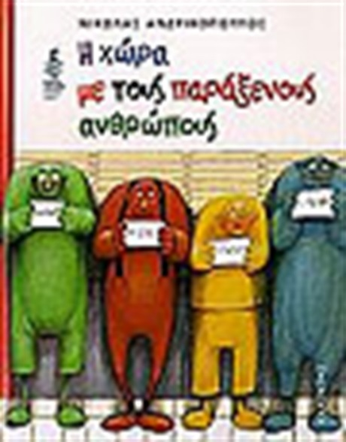

- Music
- Red clothes and white clothes to represent the people of the Redland and white land

What happens?
- The teacher tells all the students that today they will be transferred to the land of the peculiar people. They start walking and decide their peculiarity. When the music stops, they have to say what peculiarity they have.
- The teacher starts reading the book. The students sit in circle. They have to stand up in certain parts of the book and perform a part of it. For example they have to pretend to be the people of “WhiteLand” (Aspriki in Greek) that misbehave to the “RedMan” (Porfirios in Greek). Another example: They have to create- by using their bodies -the ship that the Redman used to go away, when he couldn’t stand the other peoples’ behavior.
- One good activity is the “Corridor of thoughts” that is used twice: when the Redman thinks of leaving the WhiteLand and when he thinks about changing his colour. The children are divided in two teams. Each team has to think about an advice to give to the Redman. Eg the one team advices him to leave and the other one to stay. The two teams stand in line facing each other and the Redman passes THROUGH the middle. Each time he passes in front of a pair of children they start telling him their advice eg. “Don’t Go.! It’s your country! OR Go! You are different! “.They don’t stop telling it until the Redman reaches the end of the “Corridor of ThoughtS”! In this way, they can feel the battle that happens insides one man’s brain/ self when having to take a crucial decision.
- At the end the students discuss about the end of the story. In this book the people of the Whiteland accept the Redman when he returns to his homeland only when he does something good. We point out that we shouldn’t wait for a person to do something good in order to accept him. Differences should be accepted and valued from the beginning.

