ERASMUS + PHYSICAL EDUCATION COMPARED
IES CARLOS III AGUADULCE (ALMERÍA)

Project description

- First of all, at the beginning of the course the KIDMED TEST will be passed on to all the students individually.

- Likewise, as a complement to the data collected in the Kidmed test questionnaire, the students will perform physical tests to know their level of physical condition, which are:

  - Resistance: Test of Cooper and Course Navette
  - Speed ​​and agility: 40m and 10x5 m
  - Flexibility: Wells Dilon test (Sit and reach)
  - Strength: Medicine ball throw, horizontal jump and abdominal (30 seconds)

- On the other hand, they will be measured and weighed so that they know if the diet they follow matches the weight and height they should have approximately according to their age range.

- Halfway through the course, the students will carry out an analysis of their diet for a whole week. In him they will have to consider the Kcals that they consume and those that they spend in function of their daily physical activity.

- After this activity, the teaching of basic theoretical contents on a healthy diet linked especially with the Mediterranean diet will be carried out.

- Finally, at the end of the course, the KIDMED TEST will be passed on to all the students individually and the results will be compared with those obtained at the beginning of the course.

TEST KIDMED

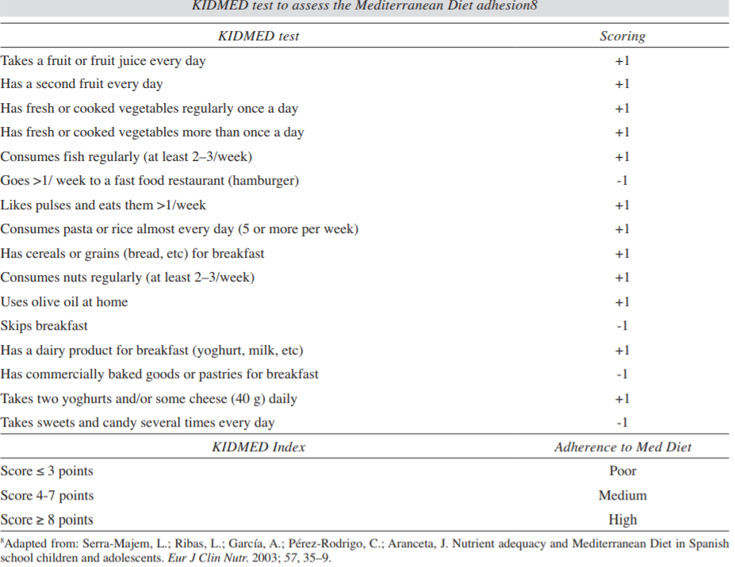

PHYSICAL TESTS

Sit and Reach Flexibility Test
The sit and reach test is a common measure of flexibility, and specifically measures the flexibility of the lower back and hamstring muscles. This test is important as because tightness in this area is implicated in lumbar lordosis, forward pelvic tilt and lower back pain

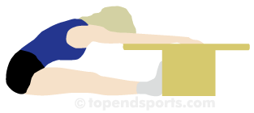

- procedure: This test involves sitting on the floor with legs stretched out straight ahead. Shoes should be removed. The soles of the feet are placed flat against the box. Both knees should be locked and pressed flat to the floor - the tester may assist by holding them down. With the palms facing downwards, and the hands on top of each other or side by side, the subject reaches forward along the measuring line as far as possible. Ensure that the hands remain at the same level, not one reaching further forward than the other. After some practice reaches, the subject reaches out and holds that position for at one-two seconds while the distance is recorded. Make sure there are no jerky movements. See also video demonstrations of the Sit and Reach Test.
- scoring: The score is recorded to the nearest centimeter or half inch as the distance reached by the hand. Some test versions use the level of the feet as the zero mark, while others have the zero mark 9 inches before the feet. There is also the modified sit and reach test which adjusts the zero mark depending on the arm and leg length of the subject. There are some norms for the sit and reach test and also examples of some actual athlete results.
- validity: This test only measures the flexibility of the lower back and hamstrings, and is a valid measure of this.

Eurofit Sit Up Test
This test of abdominal strength and muscular endurance forms part of the Eurofit Testing Battery.

- purpose: This test measures the endurance of the abdominal and hip-flexor muscles.
- equipment required: floor mat or flat ground, stopwatch, partner to hold feet.
- procedure: The aim of this test is to perform as many sit-ups as you can in 30 seconds. Lie on the mat with the knees bent at right angles, with the feet flat on the floor and held down by a partner. The fingers are to be interlocked behind the head. On the command 'Go', raise the chest so that the upper body is vertical, then return to the floor. Continue for 30 seconds. For each sit up the back must return to touch the floor.
- scoring: The maximum number of correctly performed sit ups in 30 seconds is recorded. The sit up will not be counted if the subject fails to reach the vertical position, fail to keep your fingers interlocked behind your head, arch or bow your back and raise your buttocks off the ground to raise your upper body, or let your knees exceed a 90-degree angle.

10 x 5m Shuttle Test
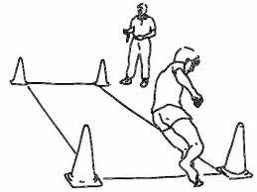
This test of speed and agility part of the Eurofit Testing Battery. Participants run back and forth over 5 meters, for a total of 50m.

- purpose: this is a test of speed and agility
- equipment required: stopwatch, measuring tape, marker cones, a flat non-slip surface
- procedure: marker cones and/or lines are placed five meters apart. Start with a foot at one marker. When instructed by the timer, the subject runs to the opposite marker, turns and returns to the starting line. This is repeated five times without stopping (covering 50 meters total). At each marker both feet must fully cross the line.
- scoring: Record the total time taken to complete the 50 m course.

20m Multistage Fitness Test. Course Navette
The 20m multistage fitness test (MSFT) is a commonly used maximal running aerobic fitness test. It is also known as the 20 meter shuttle run test, beep or bleep test among other names. For more information on this test, see the complete guide to the bleep / beep test.
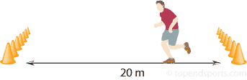

- equipment required: Flat, non-slip surface, marking cones, 20m measuring tape, beep test audio, music player, recording sheets.
- procedure: This test involves continuous running between two lines 20m apart in time to recorded beeps. For this reason the test is also often called the 'beep' or 'bleep' test. The participants stand behind one of the lines facing the second line, and begin running when instructed by the recording. The speed at the start is quite slow. The subject continues running between the two lines, turning when signaled by the recorded beeps. After about one minute, a sound indicates an increase in speed, and the beeps will be closer together. This continues each minute (level). If the line is reached before the beep sounds, the subject must wait until the beep sounds before continuing. If the line is not reached before the beep sounds, the subject is given a warning and must continue to run to the line, then turn and try to catch up with the pace within two more ‘beeps’. The test is stopped if the subject fails to reach the line (within 2 meters) for two consecutive ends after a warning.
- scoring: The athlete's score is the level and number of shuttles (20m) reached before they were unable to keep up with the recording. Record the last level completed (not necessarily the level stopped at). This norms table below is based on personal experience, and gives you a very rough idea of what level score would be expected for adults, using the standard Australian beep test version. There is a more detailed table of norms for the beep test. This level score can be converted to a VO_{2max} equivalent score using this calculator. You may also wish to download the Beep Test Recording Sheet.

Cooper 12-minute Run Test
The Cooper 12 minute run is a popular maximal running test of aerobic fitness, in which participants try and cover as much distance as they can in 12 minutes. There are several other variations of running/walking tests, including the Cooper 1.5 mile run test.
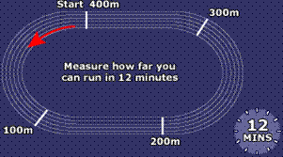

- purpose: to test aerobic fitness (the ability of the body to use oxygen to power it while running)
- equipment required: flat oval or running track, marker cones, recording sheets, stop watch.
- procedure: Place markers at set intervals around the track to aid in measuring the completed distance. Participants run for 12 minutes, and the total distance covered is recorded. Walking is allowed, though the participants must be encouraged to push themselves as hard as they can to maximize the distance covered.
- scoring: There are Cooper test norm tables for general guidelines for interpreting the results of this test for adults.

Horizontal Jump. Standing long jump
The Standing long jump, also called the Broad Jump, is a common and easy to administer test of explosive leg power. It is one of the fitness tests in the NFL Combine. The standing long jump was also once an event at the Olympic Games, and is also an event in Sports Hall competitions in the UK.
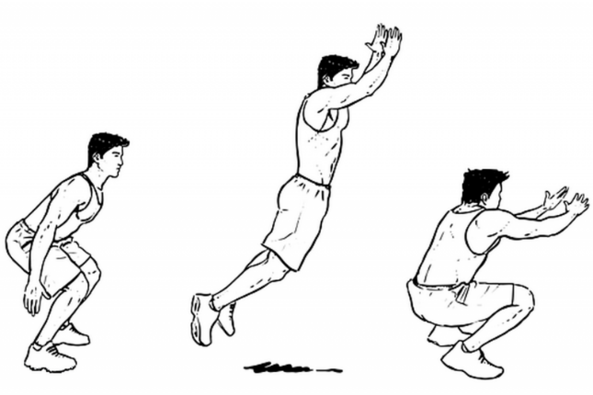

- purpose: to measure the explosive power of the legs
- equipment required: tape measure to measure distance jumped, non-slip floor for takeoff, and soft landing area preferred. Commercial Long Jump Landing Mats are also available. The take off line should be clearly marked.
- procedure: The athlete stands behind a line marked on the ground with feet slightly apart. A two foot take-off and landing is used, with swinging of the arms and bending of the knees to provide forward drive. The subject attempts to jump as far as possible, landing on both feet without falling backwards. Three attempts are allowed. See some long jump video examples.
- scoring: The measurement is taken from take-off line to the nearest point of contact on the landing (back of the heels). Record the longest distance jumped, the best of three attempts. The table below gives a rating scale for the standing long jump test for adults, based on personal experiences. See some athlete results for the long jump test. You can also use this calculator to convert cm to feet and inches.

Overhead Medicine Ball Throw (forwards)
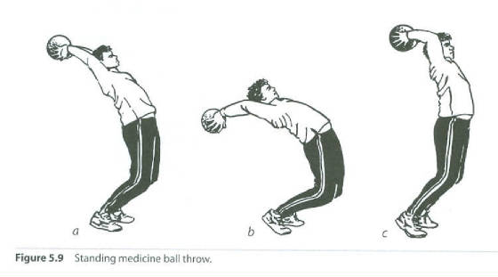

- aim: This test measures upper body strength and explosive power.
- equipment required: 2-5 kg medicine ball depending on the age group being tested, tape measure
- procedure: The subject stands at a line with the feet side by side and slightly apart, and facing the direction to which the ball is to be thrown. The ball is held with the hands on the side and slightly behind the center. The throwing action is similar to that used for a soccer/football sideline throw-in. The ball is brought back behind the head, then thrown vigorously forward as far as possible. The subject is permitted to step forward over the line after the ball is released, and is in fact encouraged to do so in maximizing the distance of the throw. Three attempts are allowed.
- scoring: The distance from the starting position to where the ball lands is recorded. The measurement is recorded to the nearest 0.5 foot or 10 cm. The best result of three throws is used.

