Short evaluation note: Sakta – task from Latvia
The task:
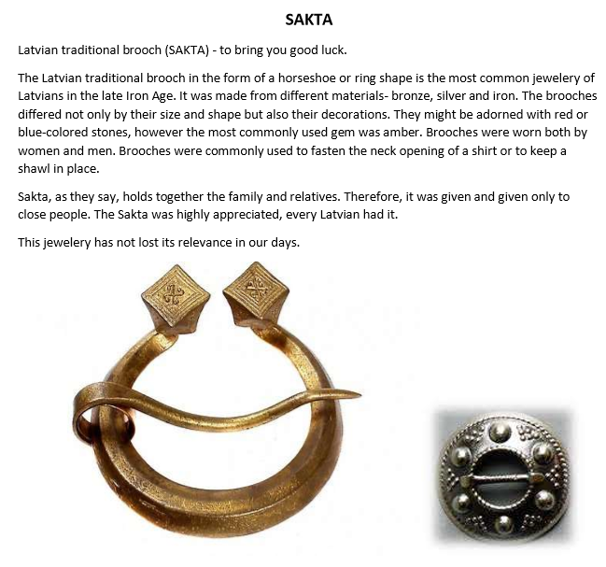

How it worked:
Students were interested to get to know more about SAKTA via Internet. They found a lot of pictures and chosed one for construction with GeoGebra. I told them that a dynamic construction would be wonderful.
But it was difficult to get a fully dynamic constructions because some lines were less than a tenth related e.g. to the biggest radius.
Here is one example:
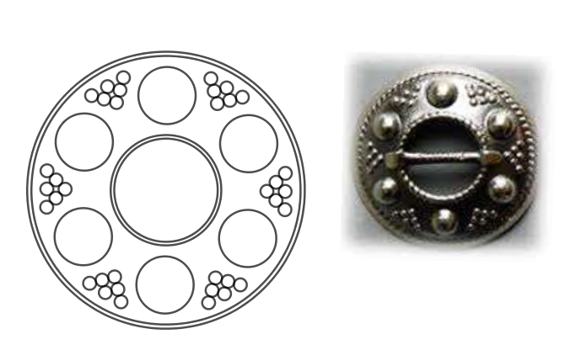

Evaluation by talking with the students:
- It was a challenge for some students.
- Some students –especially girls – liked it. For boys I should give another task.
- Time of 45 min. was too short. Students finished the construction at home.
- Thin spaces between two lines could better be realised by a single thick line.
- The knowledge about technic how to rotate different objects in a construction at the same time is important for successfully finishing the construction.
- A full dynamic construction is rather impossible and takes too much time.

Monika Schwarze , January 2018

