GeoGebra in the Classroom: Art Lessons
We have commonly collected examples of maths lessons in which GeoGebra helps to deepen understanding, creates situations of discovering basic concepts by the students themselves or lead to motivating tasks that have to do with real life.
Topic | Concrete Ideas for work with GeoGebra
Perspective: parallel perspective, central perpective | Exploring the difference, constructing it instead on paper with compass and ruler  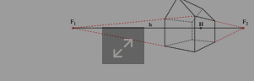  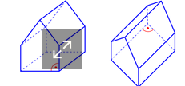  pictures
Gothic or romanic windows in churches | Getting to know the principles  of geometric construction like  trifoil or arches  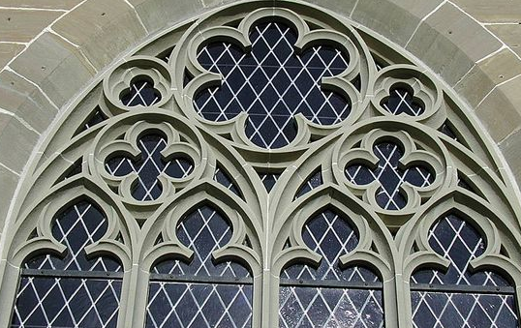  picture
GeoGebra string art | 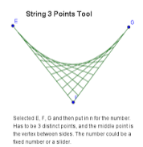  String art normally is hand-craft. But it can be done also by geogebra. The advantage is that you can animate points on a (hidden circle)
Optical illusions and paradox figures  Lesson plan on the internet  Results of my own class | 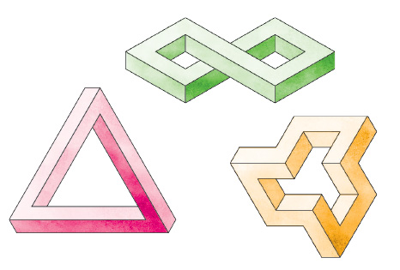  picture
Using GeoGebra as an animation tool  Lessons plans on the internet | Modelling annd simulating real life objects  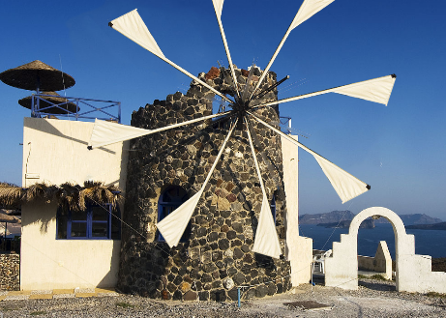  picture
Artists who create geometric art | My collection on pinterest  see also Daniel Mentrard  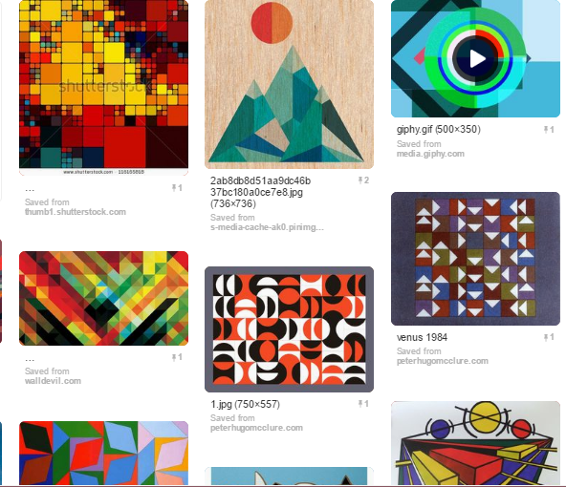
Minimal art (animated) | 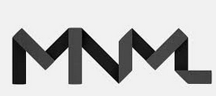  picture
Islamic art  see Classroom resources in the internet | 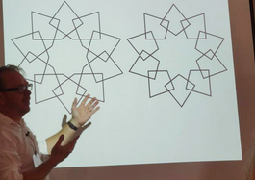  picture
Tesselations and the art of Escher | 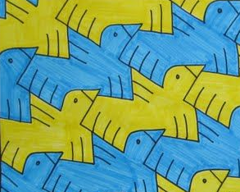  picture
Golden Ratio in Art | How to construct it? Investigation  of buildings or paintings to discover  the golden ration  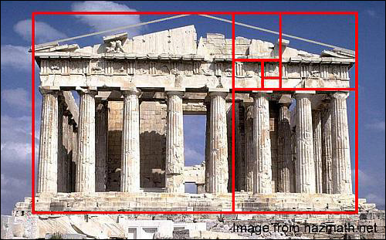picture
Fibonnacci Art Project  See lesson plan on the internet | 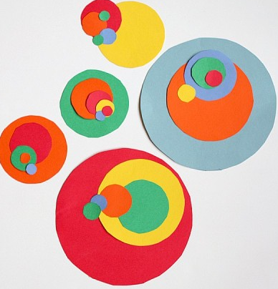  The advantage of using GeoGebra is that the positition of the circles and be changed. The disadvantage are the colors for intersecting circles
Geometric art | There are many ideas related to art topics and maths  See link to Google search

