GeoGebra in the Classroom: in Physics Lessons
We have commonly collected examples of maths lessons in which GeoGebra helps to deepen understanding, creates situations of discovering basic concepts by the students themselves or lead to motivating tasks that have to do with real life.
Topic | Impact of working with GeoGebra
Analysing motions and simulating with Geogebra.
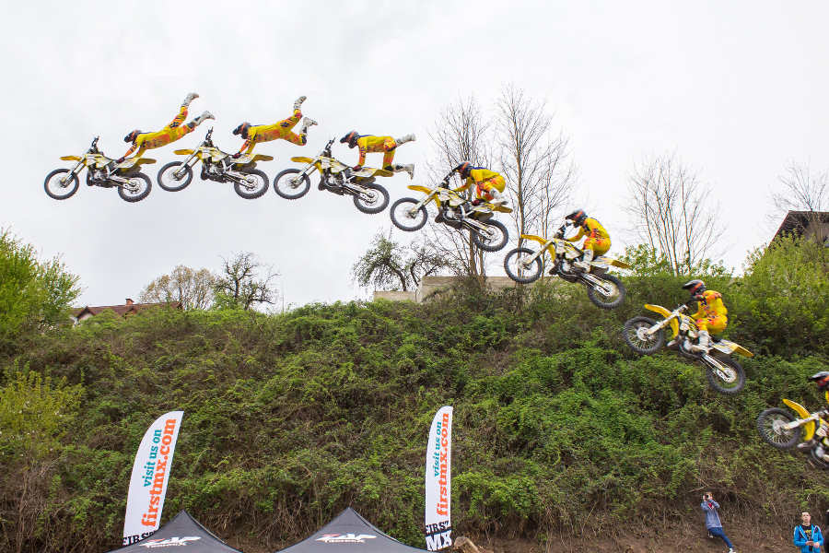picture
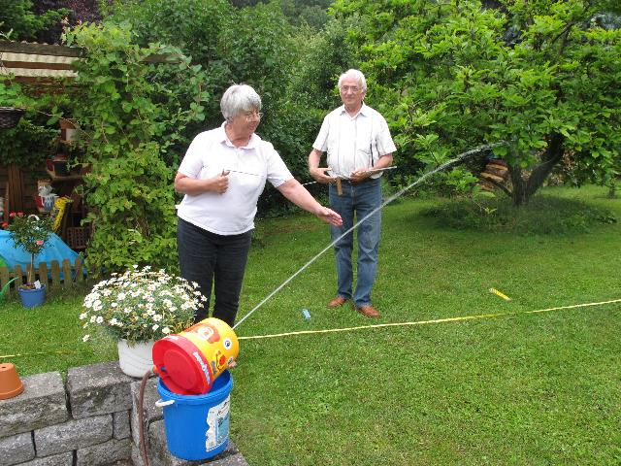
picture
Optical phenomena like refraction of light, working of the lense in our eyes, optical illusions,  Interaction of forces, …  The collection of GeoGebra-files can be downloaded from a German website. | e.g.  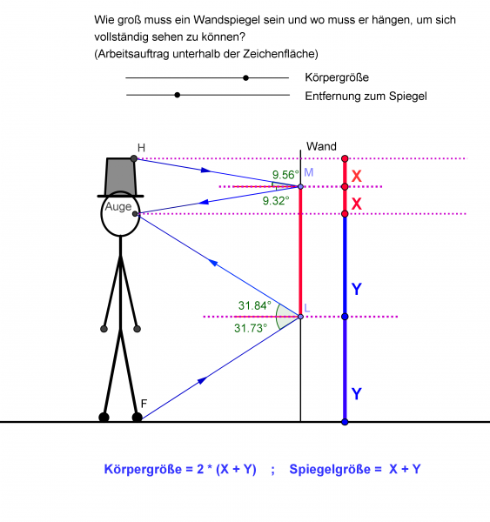  picture  Normally students get GeoGebra files, ready constructed, ready for discovering phenomena
Simulation of a pinhole camera | 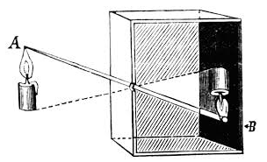  picture  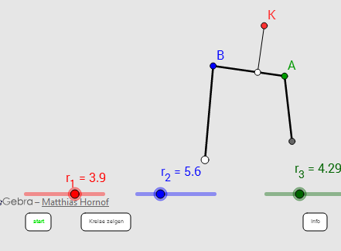
Exploring linkages (file) or other mechanical linkages.

