**Google SketchUp Short Reference**

Parts are translated from a German tutorial from [Hochschule Bochum](http://www.hochschule-bochum.de/fileadmin/media/fb_v/labore/photogrammetrie/5._Semester_Vertiefer/Google%20SketchUp%20Kurzanleitung.pdf)

## Personalizing the Toolbar

* + - Click on View  Toolbar
    - Mark with a tick like in the picture

**Starting a project**

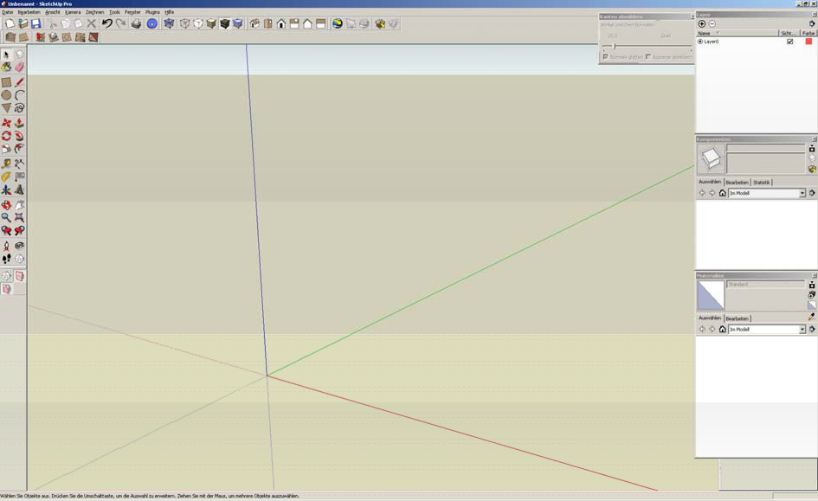

Your screen should look similar like in the picture. You may delete the person in the center.

## Defining lengths (not always important)

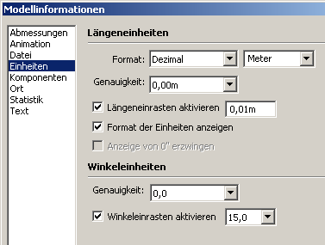Window  Infromation about the   
model  units

Modify like in the picture.

**Basic functions**

* 1. **Save**  **use reguarly!**

## Do/undo actions

* 1. **Views **
  2. **Modi for representation of the model**

 Die Wichtigsten:

1. View, textures included (standard)

2. 1. 3.

Model only with wireframe

## 5. Selection tool

## One click on an element: selection of a line or an area

## Two clicks on an element: selection if an area and all defining lines or selection of a line and all souurounding areas

## Three clicks on an element: all relevant lines, areas of the object (connectd to the place where you clicked re marked

1. Shows orientation of the surface

## Construction Tools



mearasurements right at the bottom in the toolbar:

**Line:** you can type in the length using the keyboard 

**Rectangle:** type length; semicolon; depth 

**Arc:** number of corners, radius 

**Polygon**: input of number of corners and radius

## Modification Tools

### Translation:

* + - Translating marked elements of the construction
    - After ENTER the elements will be copied

### Rotation:

* + - Input of the angle: 

### Follow-Me tool:



* + - Eine Fläche entlang eines Pfades duplizieren



### Skalieren:

* + - Shift: Scale oft he object
    - Control: Scale aouromarked unf the midpoint



**Push/pull tool:**

* Push/pull a marked area:

Offset Tool:

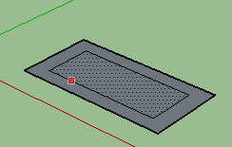

Chosen element will be copwith an offset   
interior or exterior the area

## Navigation:

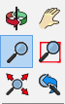

Function for rotation of the axes, pan the window right or left, and Zoom settings.   
The button right at the bottom is to get back to the last view or window setting