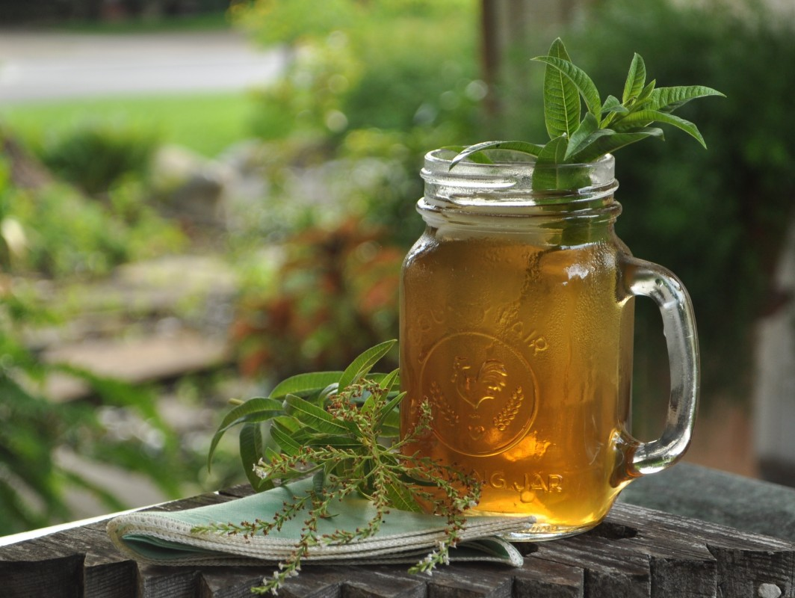

The infusion of verbena
Take 2 teaspoons of dried verbena. Pour about 150 ml of boiling water. Brew covered for 10-15 minutes. Drink the infusion 3 times a day about half a cup.
Wraps with verbena - for external use
A handful of dried verbena. Pour approx. 150 ml of boiling water. Leave it covered approx. 10 minutes. Then soak a cotton ball and bathe your skin twice or 3 times a day.

