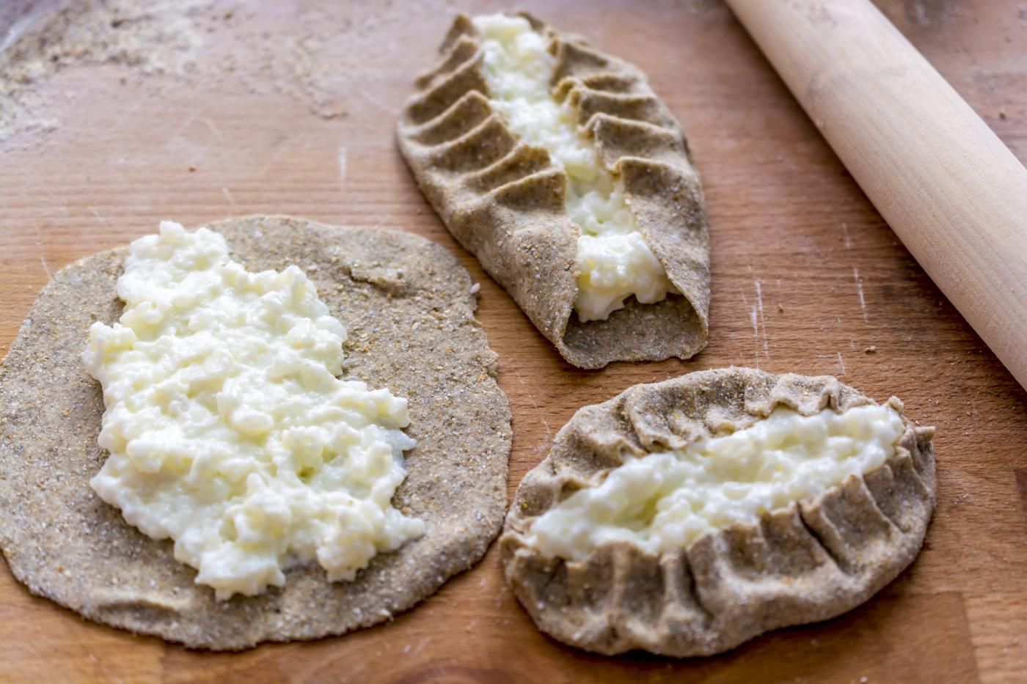
Karelian pastries
Erasmus+ team Finland | 23.5.2016

  - Preparation time 1.5-2 hours

Ingredients:
3½ dl rye flour
½ wheat flour
2 dl of water
1 teaspoon salt
1 tablespoon oil

Filling:
2 dl rice porridge
1 l milk
1 teaspoon salt
1 tablespoon oil

Instructions

Make a dough with cold ingredients. Mix flour, salt and oil. Put the dough in the fridge and make a porridge the usual way. Cool the porridge and set the oven to 250-270⁰C. When the porridge is cooling down take the dough and cut it into about 15 pieces, roll the pieces round, press them gently in the flour and roll them flat. During the rolling, use a lot of rye flour that the dough doesn’t stick in the table. When the dough is rolled you can start to fill them with the porridge. Crinkle edges and put pies into the oven for 15-20 minutes.

Kirjoita uutiskirjeen tietojen yhteenveto tai anna lisätietoja yrityksestä.

Paula Koskela
Erasmus+ team Finland
[Kirjoita lähettäjän yrityksen osoite]
[Kirjoita vastaanottajan nimi]
[Kirjoita vastaanottajan yrityksen nimi]
[Kirjoita vastaanottajan osoite]

