[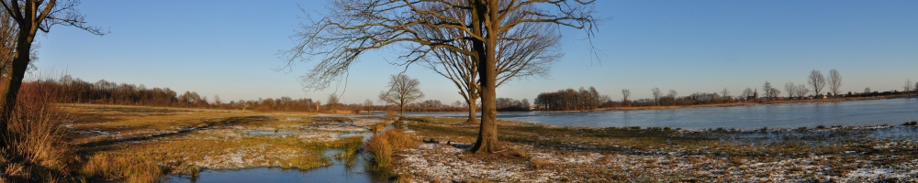](http://www.google.nl/url?sa=i&rct=j&q=&esrc=s&source=images&cd=&cad=rja&uact=8&ved=0CAcQjRxqFQoTCN-wxIOX08gCFYY-FAodvr4KXg&url=http://www.natuurlandschap.nl/wouter2/flora-en-fauna-van-nederland/reptielen-en-amfibieen/adder/&bvm=bv.105454873,d.bGQ&psig=AFQjCNGP7W-3yixvDC1lcTxiXphkQUz7Ew&ust=1445503643001081)[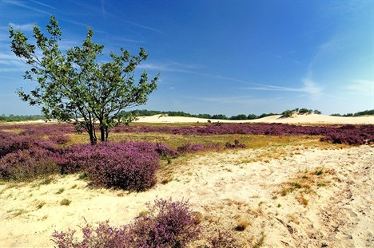](http://www.google.nl/url?sa=i&rct=j&q=&esrc=s&source=images&cd=&cad=rja&uact=8&ved=0CAcQjRxqFQoTCJyTk7iW08gCFYpxFAodoTcKUw&url=http://helvoirt.net/openluchtdebat-nationaal-park-de-loons-en-drunense-duinen/&psig=AFQjCNFrjoogU26X_a3v1-Q7oubt3odqlQ&ust=1445503487625930)[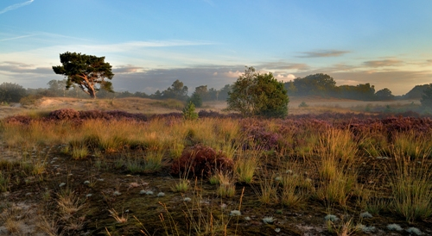](http://www.google.nl/url?sa=i&rct=j&q=&esrc=s&source=images&cd=&cad=rja&uact=8&ved=0CAcQjRxqFQoTCLiguKmW08gCFUZCFAodctYNnA&url=http://www.np-deloonseendrunenseduinen.nl/&psig=AFQjCNFrjoogU26X_a3v1-Q7oubt3odqlQ&ust=1445503487625930)[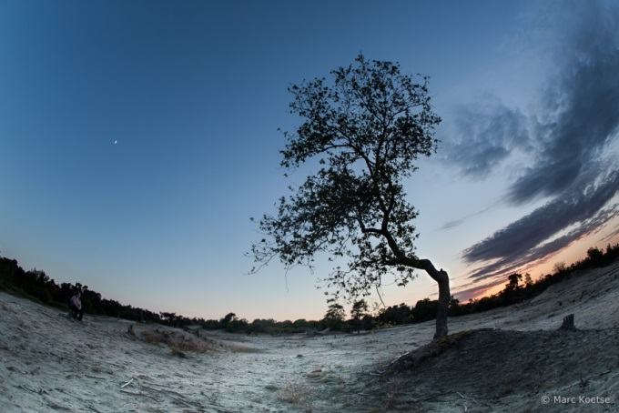](http://www.google.nl/url?sa=i&rct=j&q=&esrc=s&source=images&cd=&cad=rja&uact=8&ved=0CAcQjRxqFQoTCIqnjfuX08gCFchvFAod4egEvg&url=http://www.kokomove.nl/tag/loonse-en-drunense-duinen/&bvm=bv.105454873,d.bGQ&psig=AFQjCNGP7W-3yixvDC1lcTxiXphkQUz7Ew&ust=1445503643001081)

[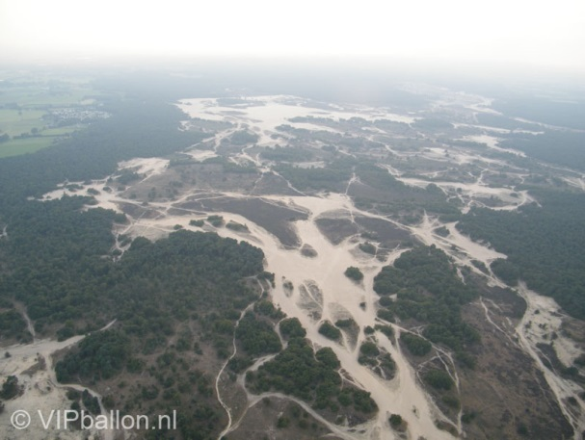](http://www.google.nl/url?sa=i&rct=j&q=&esrc=s&source=images&cd=&cad=rja&uact=8&ved=0CAcQjRxqFQoTCMuSi9yY08gCFctAFAod3-UPDg&url=http://www.vipballon.nl/ballonvaren-den-bosch/&bvm=bv.105454873,d.bGQ&psig=AFQjCNGP7W-3yixvDC1lcTxiXphkQUz7Ew&ust=1445503643001081)

**Tips:**

**1.It’s in Noord-Brabant**

**2. It’s also called the “Brabantse Sahara”**

**3.The area is 35km²**

**4.There is a lot of sand**

**5.There are a lot of animals**

.

[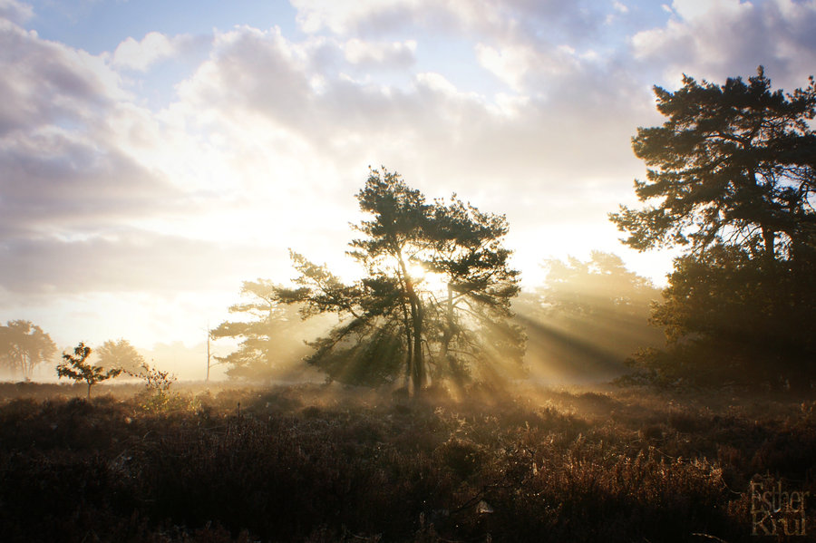](http://www.google.nl/url?sa=i&rct=j&q=&esrc=s&source=images&cd=&cad=rja&uact=8&ved=0CAcQjRxqFQoTCLiguKmW08gCFUZCFAodctYNnA&url=http://estherkrul.deviantart.com/art/Loonse-en-Drunense-duinen-331166801&bvm=bv.105454873,d.bGQ&psig=AFQjCNFrjoogU26X_a3v1-Q7oubt3odqlQ&ust=1445503487625930)