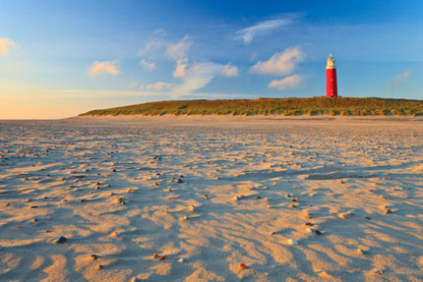
Pictures:

Tips:
1 People live there.
2 There are 5 of them.
3 There are seals.
4 There is a lot of beach
5 TV TAS………
