PARISH CHURCHES

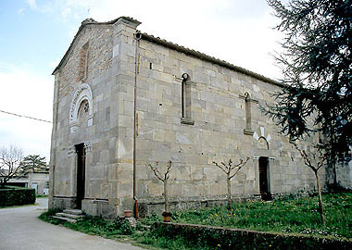

In Lucca and in its territory and villages there are very many churches.
Some churches have the medieval origins , others are from the XVII-I c.
The churches are almost entirely made ​​of stone and some in white marble ..

