LEGTA DE CROIX-RIVAIL – MARTINIQUE

Our High School is named the L.E.G.T.A. DE CROIX-RIVAIL, LEGTA means General, Technological Agricutural High School . The LEGTA is situated in Ducos (Croix-Rivail district), not far from the Aimé Césaire Airport. It’s on top of a hill and its superficy is 17 hectares. We have a farm in our school ( animal husbandry, vegetables production) . The LEGTA is a public school with three sections: a general , technological and vocational section, related to agriculture.
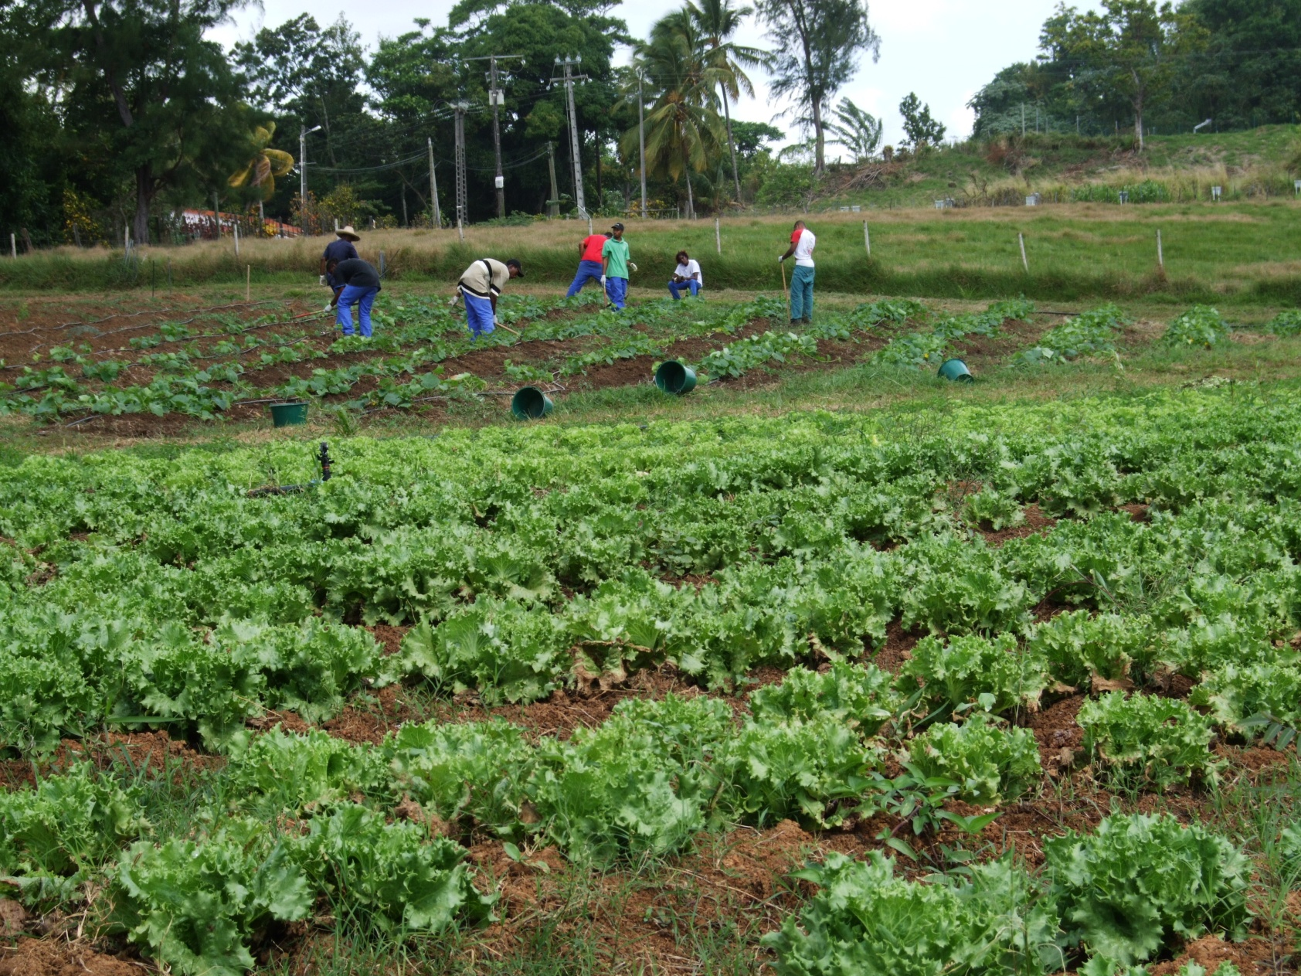
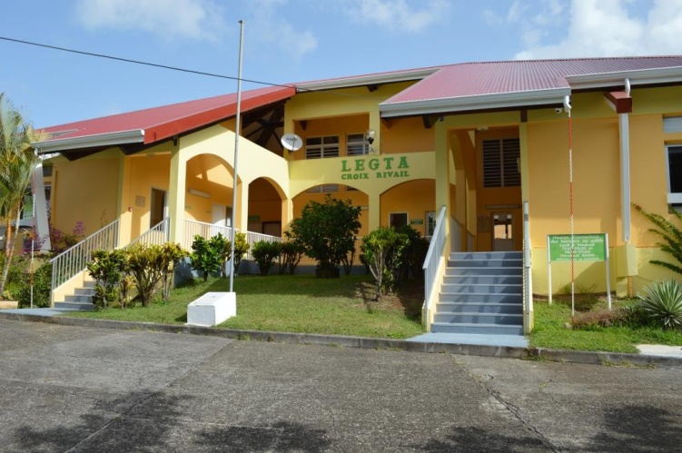
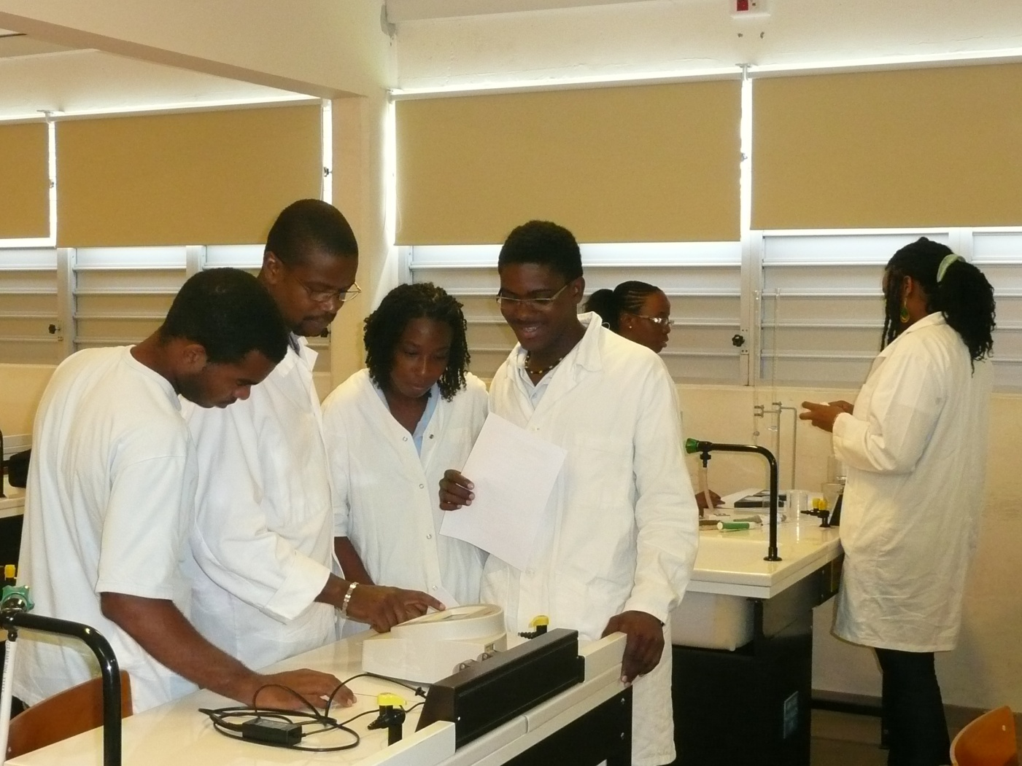

This year we have 270 students aged from 15 to 20 years old, from 10th grade to 12th grade and we also have older students who are preparing a degree in biological agriculture.
Some of our students’ parents have low income , they own a farm that’s the reason why their children choose to attend an agricultural high school.
The LEGTA’s facilities: sport facilities, computers, library, canteen , a boarding high school for girls and boys make it possible to give the students a quality education . The boarders are hosted from monday to friday since the students come from different part of Martinique and our Island suffers from a scourge that can be found in any european capital: traffic jams.
With the support of teachers, the students run a school organization: The ALESA: Students, Interns, Apprentices Organization. They organize recreational, cultural and sport activities.
The sudents who take parti in the Erasmus+ partnership attend the “European Section” and they have biology , physics and chemistry lessons in english.
