[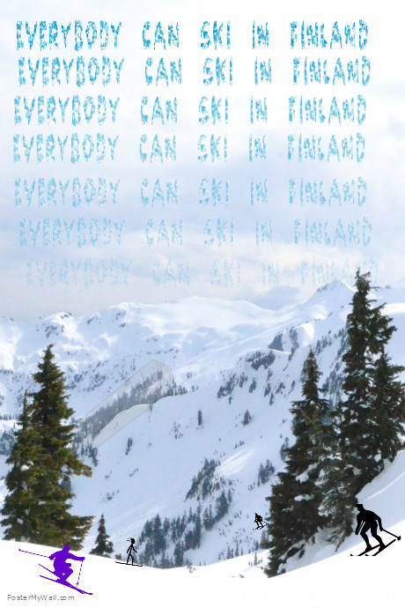](http://www.postermywall.com/index.php/posterbuilder/load/6de59f7a78749a6c1b7afe4bba3678c5)