Puerta de Alcalá: The Door of Alcala: Madrid. (Spain)
The Puerta de Alcalá: Madrid. (Spain)
Introduction:
The Puerta de Alcalá is one of the five ancient Royal doors that gave access to the city of Madrid.
It is located in the Centre of the roundabout of the independence square, designed by the urban planner Angel Fernández de los Ríos in the year 1778. At the intersection of the streets of Alcala, Alfonso XII, Serrano and Salustiano Olózaga, next to the gates of the retirement: door of Spain, door of independence (main entrance to the the Retiro gardens) and door of Hernani.
The door gave access to travelers who entered formerly people from France, Aragón or Catalonia. Today is a monumental door which is located next to the fountain of Cibeles and the Retiro Park. It was built by order of Carlos III instead of another front door already existing since the 16th century. Design and work belong to the Italian architect Francesco Sabatini.
He is a door style neo and monumental appearance similar to the arches of the Roman triumphs, was erected facing the exterior to East in the year 1778.
The originality of its factory is to be the first Arch of triumph built in Europe after the fall of the Roman Empire, being forerunner of others as the Arc de Triomphe of Paris and the Brandenburg Gate in Berlin.
Function:
It has undergone since its inception various urban transformations in their environment. Going be external border de Madrid, to a resort of obliged passage that appears inserted almost in the middle of the city.
Finally since 1976 is considered by the Spanish State as a historical-artistic monument, extending its category to the same independence square.
The door, was acquired from late 18th century relevance in the Madrid village, and at the end of the 19th century it was already one of its most characteristic icons appearing in numerous illustrations of the city. As one of the most representative monuments, double as a look into the interior of the city and to the outside of it. the Puerta de Alcalá has served as support for all kinds of political and artistic manifestations and in its surroundings numerous historical events have occurred.
History:
The city of Madrid since its inception, has numerous doors and gates of access to the city through its wall.
In the middle ages the defensive castro at the position of the old fortress made to build a defensive wall to your around. This wall had a series of outputs or notable doors that transited among the population. The walls and gates had a character of fiscal control of goods, at the same time as defensive.
As the city grew in size, the wall was larger, it was known as Christian wall that marked new limits.
With the arrival of Felipe II in 1561 and the establishment of the Court in the city, the villa has an unprecedented demographic growth.Dara place a new number of doors and gates.Andbetween them was that of Alcalá.
The exits of Madrid were flanked by five real doors or registration (i.e. those in which taxes are paid):
- Door de Segovia (also called the Puente de Segovia.)
- Door deGuadalajara, Toledo, Atocha, Alcalá and Bilbao.
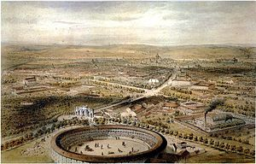
Puerta de Alcalá in 1854.
Currently:
The Puerta de Alcalá is part of the typical sightseeing tours of the city, because it is halfway between the Cibeles and Retiro.
In 2004, on the occasion of the wedding of the Prince Felipe, the door had special lighting for several days, as other monuments of the city,.
Architecture:
The Puerta de Alcalá develops its architecture in three bodies, the two sides to lower height than the central. Among their three bodies are dealt five vain total: three with arch semicircular, with keys finishes its segments figureheads with forms of Heads of leon (West side or inside) and satyrs (side this or outside), and two side with lintel arches decorated them with two pairs of cards with reliefs of cornucopias crusades (West side or inside) and floral motifs in the form of garlands (side this or outside). These central spans already had a few years of its construction, of bars that were closed to traffic every day at sunset. Now you can see the bushings on which it stood and turned this lattice. Other exterior openings are intended for the passage of pedestrians. In plant central body protruding from the sides.
The exterior façade, one that looks to the East, presents ten townhouses Segovia granite columns. They are all smooth and without ridges.
In the interior, looking towards the city, the six exterior shall be replaced by pilasters and only two pairs next to the central arch are still columns. All of them rely on a socket. The capitals are from Ionic and over them relies one cornice. They are of the same design made by Miguel Ángel to factory of the Capitol in Rome. They were made to bring the models at the time to suit the design of the door.
^{Decoration:}
The main artists of the decorations are two: the Spanish sculptor Francisco Gutiérrez (shields and Angel sharks from the outside) and French Roberto Michel (Lions, Bugles and other decorations of the interior).
On the central span, in the attics of both facades, Gable figure an inscription in latin with the slogan in three lines:
III CAROLO REGE
ANNO
MDCCLXXVIII
Iconography:
Charles III wanted to build the door as a symbol of the Memorial of his first entry into Madrid, while I got the beautification of the city by one of its main entrances.

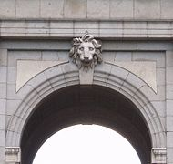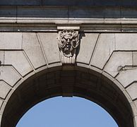
Lion's head, part West. Head of Satyr, eastern part

Cornucopias: symbol of abundance.

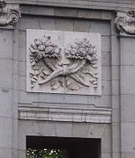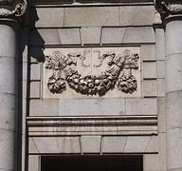
Cornucopia in the part of the West. In the eastern part of the vase.
Figures from the Pediments:

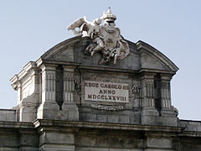 Coat of arms, supported by fame.

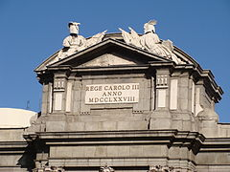 Lying war trophies (torsos)

The four virtues:
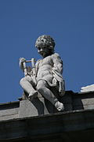Temperance with your bracket.

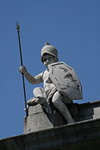The fortress with his spear and shield.

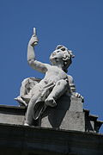 Prudence with its mirror.

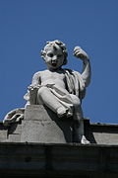 Justice, carries a balance.
Armor - shields: All of them are an allegory of the exaltation of the peace.

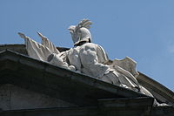Coat of arms of the right side panelling.

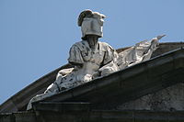Coat of arms of the frieze, left.
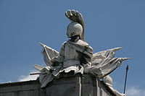Coat of arms of the right.

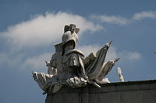Coat of arms of the left

