Come to my Italian “PIZZERIA”
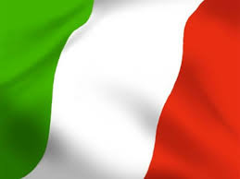
Try my special pizza with:
- …………………………………………………………….

- …………………………………………………………….

- …………………………………………………………….

