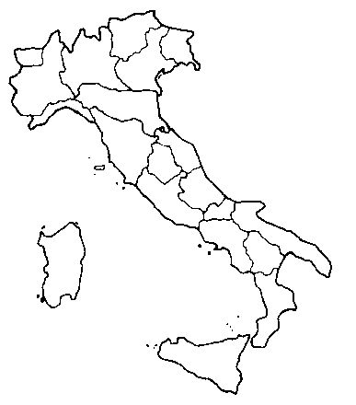
What do you remember about ITALY?

How many regions in Italy? | □ 30 □ 20 □ 19
What’s the name of the capital city of PIEMONTE? | □ Rome □ Turin □ Florence
What’s the name of the capital city of ITALY? | □ Rome □ Turin □ Naple
How much territory is covered by mountains | □ 70% □ 40% □ 50%
Which is the longest river? | □ Po □ Adige □ Tevere
Which country doesn’t border Italy? | □ France □Germany □ Slovenia
Which is the biggest lake? | □ Lago di Garda □ Lago Maggiore
Where can you find orange trees in Italy? | □ Piedmont □ Sicily □ Sardinia
What’s the name of the mountain that is 3841 m high? | □ Monte Bianco □Monviso □Cervino
Do you remember some object invented by Italians | □ telephone……………………………
What’s the population of Italy? | □59,083,000 □56,723,212

